Willie Coleman
May 19, 1940 – August 18, 2001

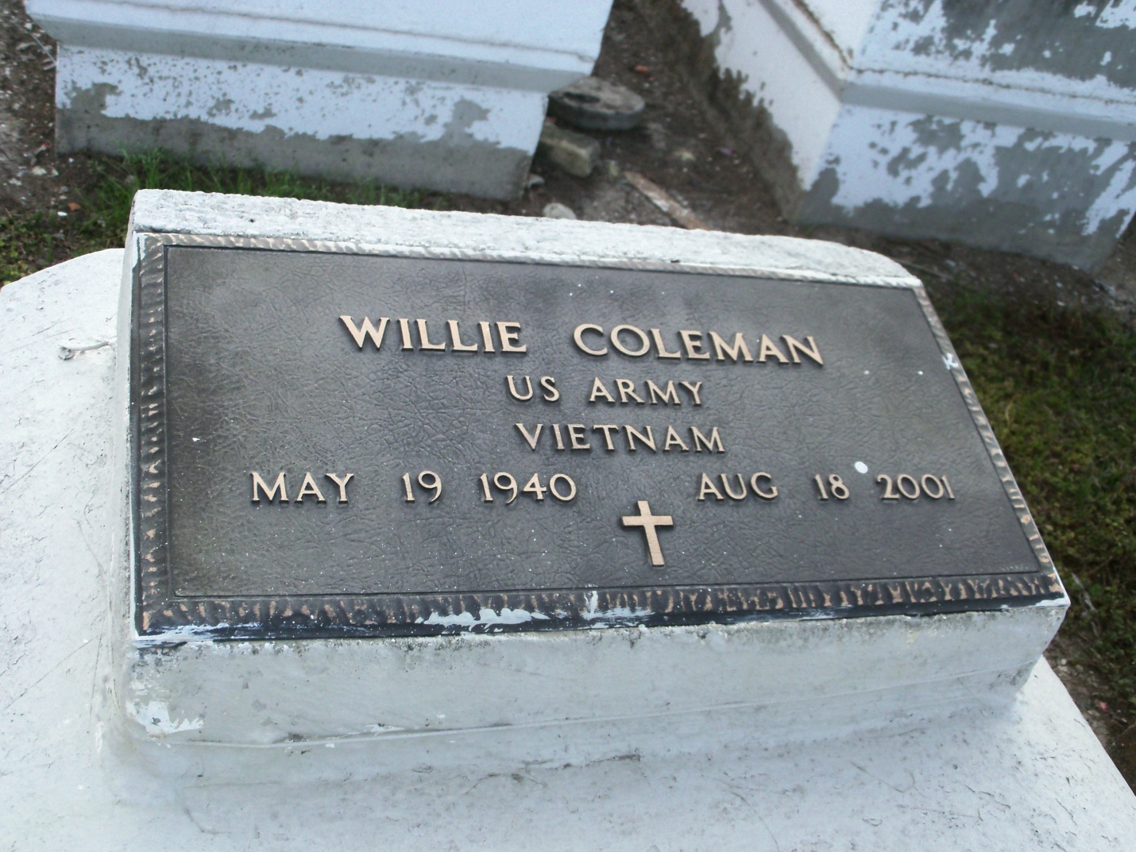
Photo by GeniHound

MONTZ - Willie "Dunk" Coleman, 61, a resident of LaPlace, died Aug. 18. He
was the husband of Ruth T. Coleman and father of Anastasia Bourgeois, Chad and Ronaldo Coleman and stepfather of Robert and Neesa White. He was the son of the late Henry Sr. and Eliza Coleman and brother of Carrie Donsereaux, Mary Lee Williams, Joyce Brown, Janet Dixon, Rubie Dodson and the late Henry Coleman Jr. He is survived by two grandchildren and five step-grandchildren.

Services are today at noon at Providence Baptist Church No. 2, Montz, with
interment at Zion Travelers Cemetery, Lions. Visitation starts at 10 a.m.

L'Observateur, LaPlace, LA; August 25, 2001

