Florence (Smith) Collins
January 14, 1916 – October 13, 2002

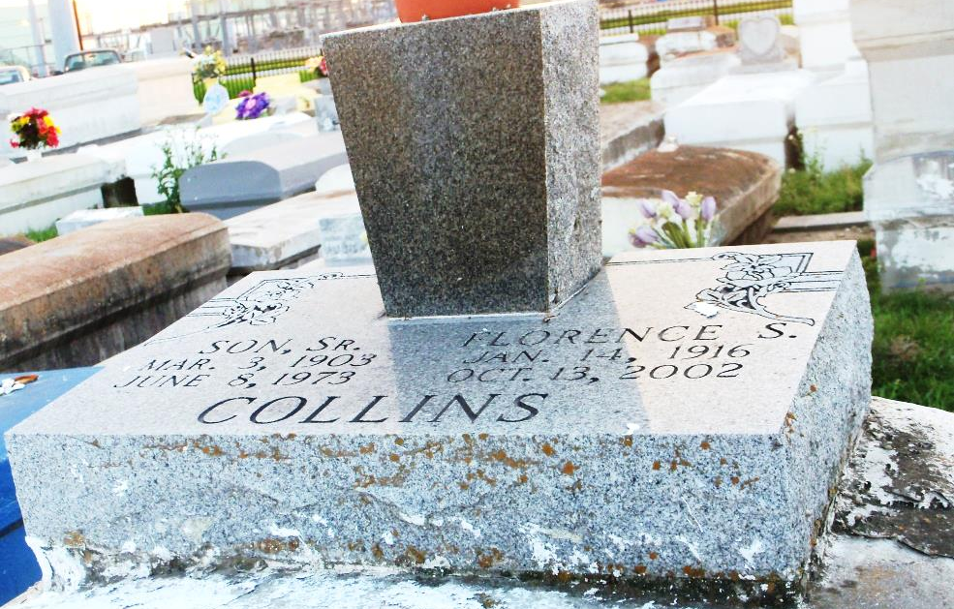
Photo by GeniHound

Florence (Momma Florence) Smith Collins of Reserve, La. on Sunday, October 13, 2002 at Metropolitan Hospice. Daughter of the late Victoria Anthony and William Smith. Wife of the late Son Collins, Sr. Mother of Gladys, Son Jr., Felton, Melven, Mary, Glenn Sr., Gwendolyn and the late Ramona, Alice Mae, Stella Louise and Raymond Collins. Guardian of Rowena M. Brown and Patricia Morgan. Sister of Hazel Perry, Ruby Anthony, Joseph Anthony, and the late Thoyd Ellis, John Mack Anthony, David Ellis, Alonzo Anthony and Clarietta Powell. Mother-in-law of Betty, Cynthia, Nickel, Dolores, Vanessa, Shelia Collins, Freddie Brooks, Lonnie Brown and Leroy Eaglin. Also survived by 27 grandchildren, 51 great-grandchildren, 8 great-great-grandchildren, 2 sisters-in-law, 2 brothers-in-law, a devoted nephew Alfred Royal, a host of nieces, nephews, cousins and friends. A native and resident of Reserve, La. Age 86 years.
Relatives and friends of the family, also pastor, officers and members of the Greater New Plymouth Rock B.C., Beech Grove B.C., Pilgrim B.C. and neighboring churches, employees of St. John School Board, St. John Sheriff Dept., Union Carbide, BMC Software, Houston, Tex., Metropolitan Hospice, members of Lillian A. Loeb Chapter #87 O.E.S. are invited to attend the funeral services on Saturday, October 19, 2002 at 12:00 (noon) from the Greater New Plymouth Rock B.C., 110 N.W. 13th St. Reserve, La., Rev. David B. Carter officiating. Interment Zion Travelers B.C. Cemetery, Reserve, La. Visitation at the church after 9:00 AM on Saturday.
The Baloney Funeral Home in charge of arrangements

Times-Picayune, The (New Orleans, LA) - Friday, October 18, 2002
Contributed by Jane Edson

