Chiquilla Renee Cooks
November 21, 1983 – April 16, 2002

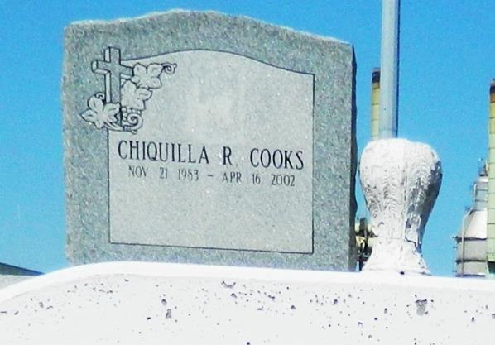

Chiquilla Renee Cooks, a senior at East St. John High School, died April 16 from injuries suffered in a car accident in Reserve. She was 18. Miss Cooks was a lifelong resident of Garyville. Survivors include her parents, Elton Miles and Donna Watkins; her grandparents, Geraldine Washington and Lillian Jackson; and two brothers, Taja Cooks and Tyrone Grover Jr. A funeral will be held today at 11 a.m. at St. Mark Baptist Church, 132 Marques St., Mount Airy. Burial will be in Zion Travelers Cemetery in Reserve. Hobson Brown Funeral Home is in charge of the arrangements.

Times-Picayune, The (New Orleans, LA) - Tuesday, April 23, 2002
Contributed by Jane Edson

