Morris Davis Jr.
May 7, 1956 – December 3, 2001

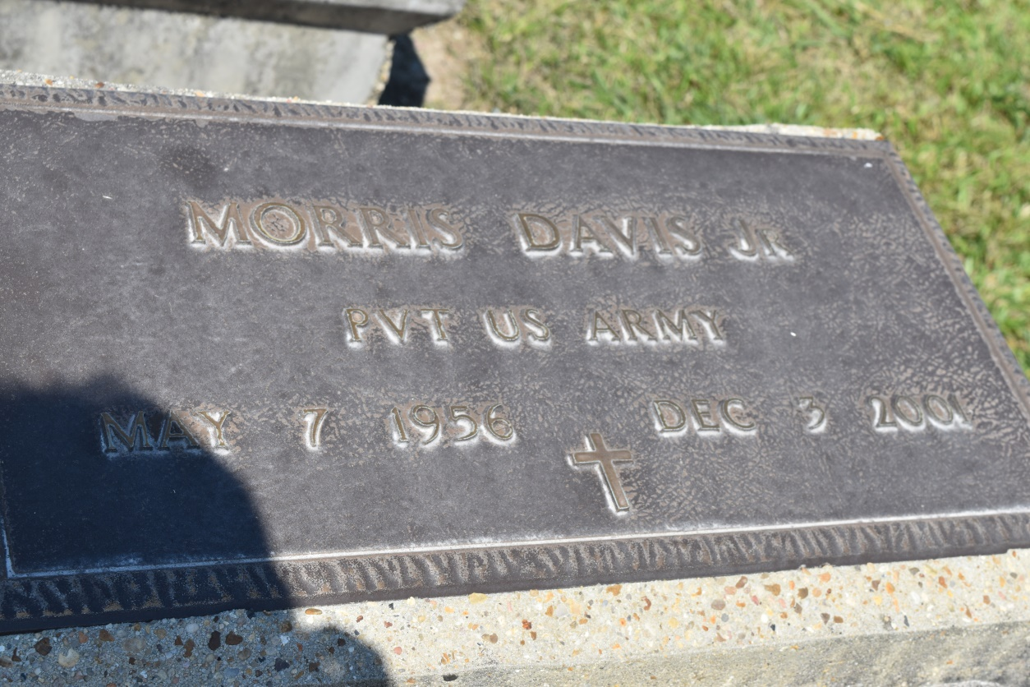

GARYVILLE - Morris "Ninny" Davis, 45, a resident of Garyville, died Dec 3. He was the husband of Pier Sterling Davis and father of Kenyatta, Latoya and Morris Davis III.
He was the son of Rosa Mae Davis and the late Rev. Morris Davis Sr. and brother of Joyce Brown, Beverly Johnson, Bernard Hayes, Mary Cobb and Betty, Eugene and Claude Davis.
He is also survived by three grandchildren.
Services are today at 11 a.m. at Greater New Mt. Zion Baptist Church, Garyville, with interment at Zion Travelers Cemetery, Lions.

L'Observateur (La Place, LA) - Sunday, December 16, 2001
Contributed by Jane Edson

