Shirley Dixon
May 7, 1949 – December 9, 2013

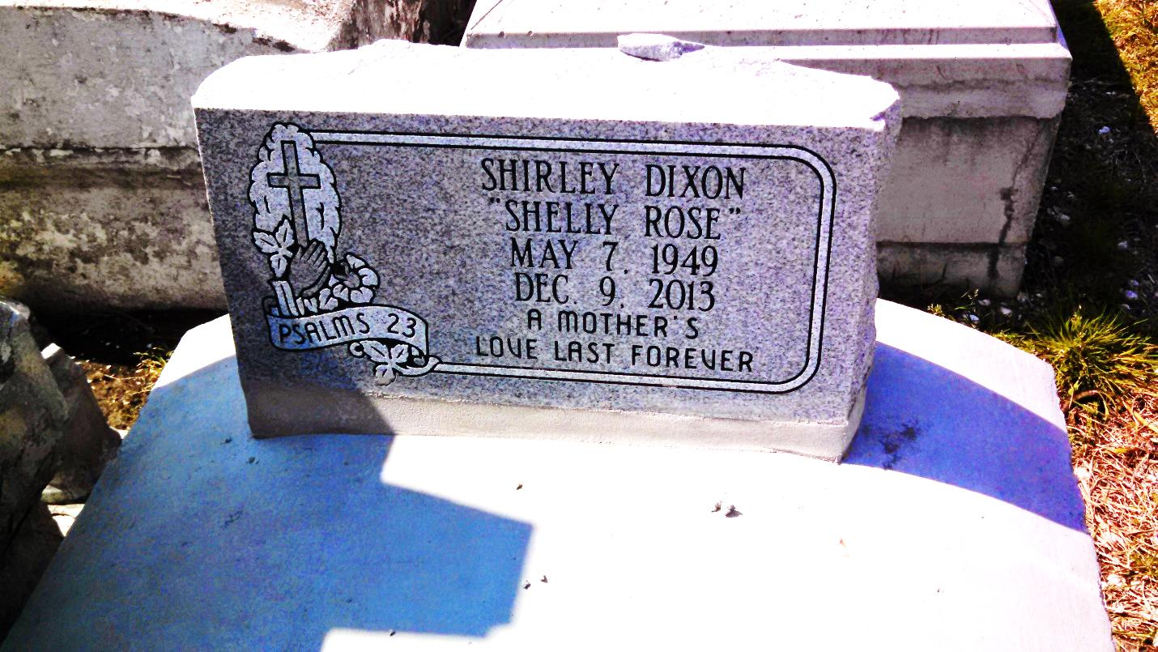
Photo by GeniHound

Shirley "Shelly Rose" Dixon, 64, a retired employee of Constar Plastics entered into eternal rest on Monday, December 9, 2013. A native of Covington/Reserve and a resident of Humble, TX. Mother of Angela, James Jr., Cheryl Dixon, Nadia Dixon-Rayfield (Bruce). 1 Sister, 1 Brother, 5 Grandchildren, 3 Great-grandchildren and a host of nieces and nephews.
Relatives and friends, also Pastors, Officers and Members of neighboring churches, former employees of Constar Plastics and employees of East Jefferson General Hospital are invited to attend the funeral services on Saturday, December 21, 2013 at 11:00 am at Israelite Baptist Church, 2192 Alexander St., Lutcher, LA, Pastor Kevin B. Fredericks, Sr. officiating. Visitation will begin at 9:00 am until service time ONLY at the above named church. Interment at Zion Travelers Cemetery. Arrangements entrusted to Verrette's Pointe Coupee Funeral Home New Roads, LA.

Times-Picayune, The (New Orleans, LA) - Friday, December 20, 2013
Contributed by Jane Edson

