Joe Whitefield Doss Jr.
June 26, 1952 – January 22, 2009

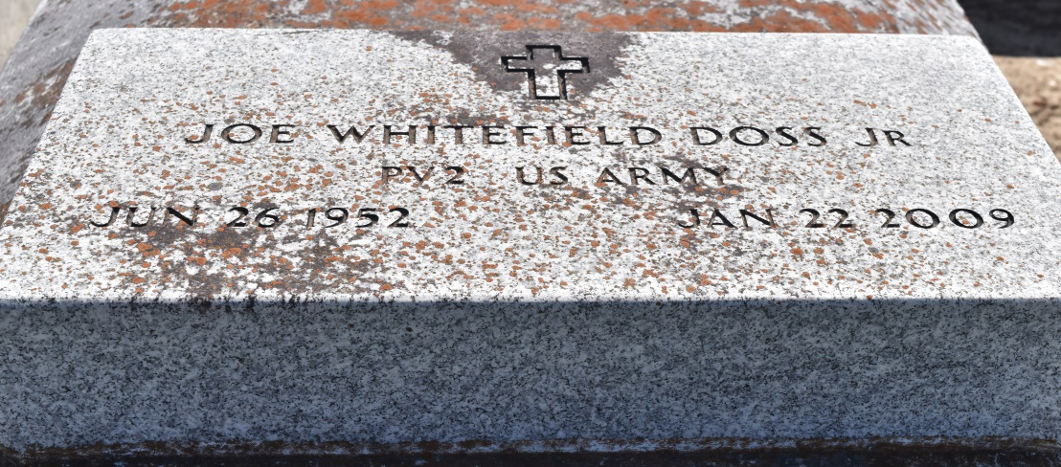

Joe Whitfield Doss, Jr., a native of Reserve, LA and a U.S. Army Veteran, on Thursday night, January 22, 2009 at 10:33 pm. Bro. Joe W. Doss, Jr. heard his master's voice saying "Servant of God Well Done". Visitation at Zion Traveler Baptist Church, 713 Walnut Street, LaPlace, La., on Friday, January 30, 2009, from 5:00pm - 8:00pm and Saturday, January 31, 2009 from 9:00am - 11:00am service time. Conducted by Rev Isiah Franklin, Jr., Pastor. Interment Church Cemetery.
Joe was the second born son to Everlena Melancon and Joe W. Doss, Sr. He was educated in St. John School Systems. He was baptized at the Greater New Mount Zion B. C. by the Rev. Wesley Anderson, Jr. He was formerly married to Loretta Brown. To that union two children were born Joe and Coretta Brown. Along with his parents and children he leaves to cherish his sweet memories, six grandchildren: Janisha and Nylasha Brown, Kilyah and Kilylay Teems, Ziy Brown and Emanuel Rayfield, Jr., three brothers: Calvin and Ketih Doss, Kenneth Melancon; three sisters: Stella Mae White, Evelyn Basile and Elouise Morris; one sister-in-law Tayna Melancon, one brother-in-law Eldrid Morris, one uncle Albert Thomas, one aunt Ora Lee Ellis, two aunts-in-law Mattie Thomas and Vanessa Thomas; three devoted friends, Steve Stewart, Jr. Gill W. Jasmine and Jeffery Lewis, and a host of nieces, nephews, great-nieces, great-nephews, cousins, other relatives and friends.
Hambrick's Family Mortuary, Gonzales, LA in charge of arrangements.

Times-Picayune, The (New Orleans, LA) - Friday, January 30, 2009
Contributed by Jane Edson

