Melvin Douglas
July 2, 1966 – September 3, 2015

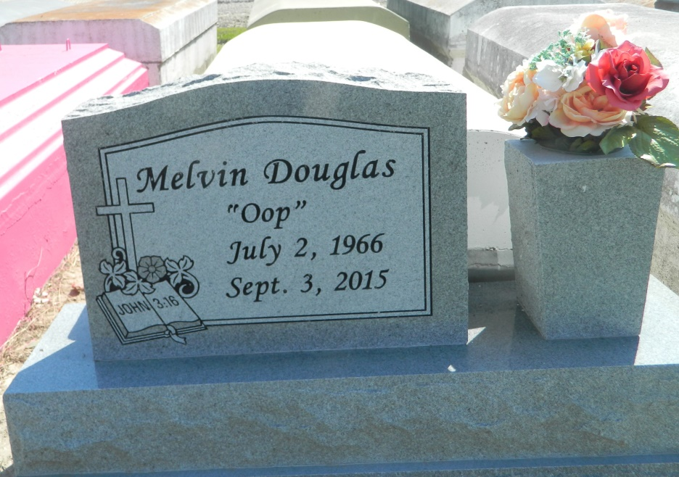

Melvin Douglas on Thursday, September 3, 2015 at Ochsner Medical Center Kenner, LA.
Son of Willie Mae Douglas and the late Monroe Douglas, Sr. Father of Keisha and Melvin Vasquez. Brother of Kady Gransberry, Earline Riley, Ruth Riley, Josephine Turley, James Macon, Sarah Riley, Linda Dees, Henry Dees, Hester Ellis, Monroe Douglas, Jr., Ruby Cotton and Christine Joseph. Also survived by 4 grandchildren and a host of nieces, nephews, cousins, other relatives and friends. Age 49 years. A native of Norco, LA and resident of LaPlace, LA.
Relatives and friends of the family, also pastors, officers and members of Greater Good Hope Baptist Church and all neighboring churches are invited to attend the Funeral Service at Greater Good Hope Baptist Church, 47 Cathey Street, Norco, LA on Saturday, September 12, 2015 at 11:00 AM. Rev. Tyrone Scott, Pastor, Officiating. Interment Zion Travelers Cemetery, Reserve, LA. Visitation at the above named church from 9:00 AM until Service Time
SERVICED BY ROBOTTOM

Times-Picayune, The (New Orleans, LA) - Friday, September 11, 2015
Contributed by Jane Edson

