Monroe Douglas Sr
January 7, 1913 – December 28, 2003

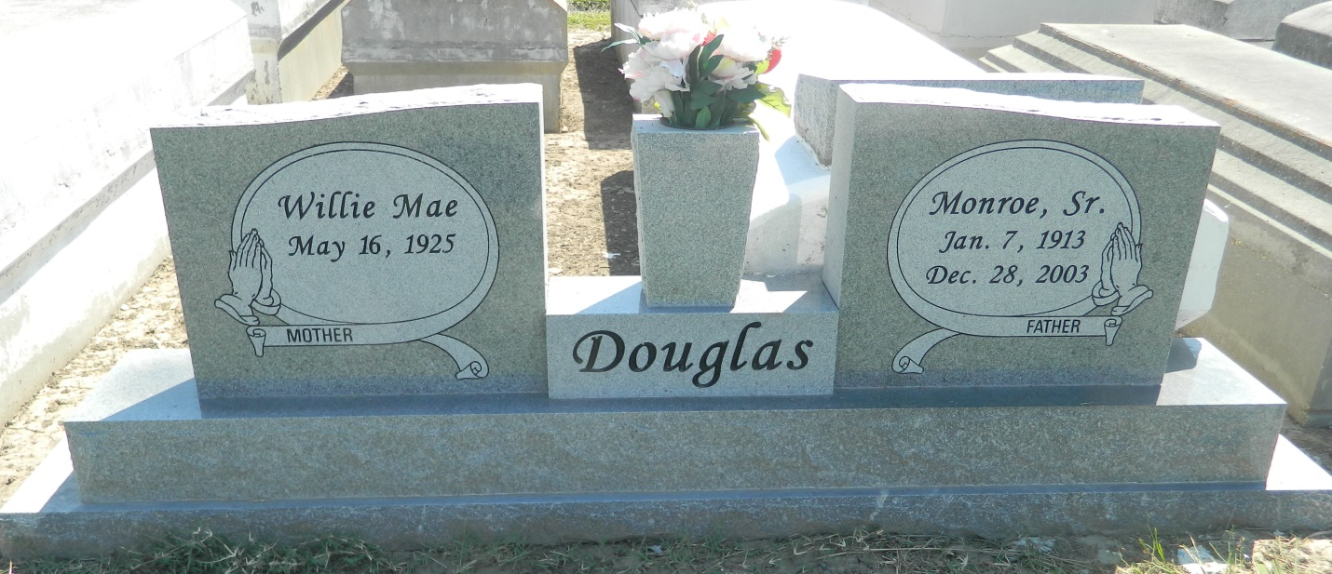

Monroe Douglas, a retired railroad worker, died Sunday at Ochsner Foundation Hospital. He was 89. Mr. Douglas was born in Scotlandville and lived in LaPlace. Survivors include his wife, Willie Mae Dees Douglas; four sons, James Macon, Henry Dees, Melvin Douglas and Monroe Douglas Jr.; nine daughters, Katie Grassberry, Earline, Sarah and Ruth Riley, Josephine Turley, Linda Dees, Hester Ellis, Ruby D. Cotton, and Christina D. Joseph; 40 grandchildren; 98 great-grandchildren; a great-great-grandchild; and a great-great-great-grandchild. A funeral will be held Saturday at 11 a.m. at Greater Good Hope Baptist Church, 47 Cathy St., Norco. Visitation will begin at 10 a.m. Burial will be in Zion Travelers Cemetery in Reserve. Robottom Mortuary is in charge of arrangements.

Times-Picayune, The (New Orleans, LA) - Friday, January 2, 2004
Contributed by Jane Edson

