Raymond Ducre
June 7, 1928 – April 15, 2003

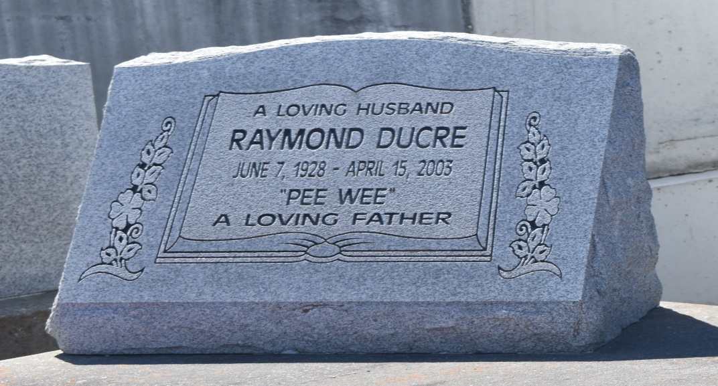

Raymond 'Pee-Wee' Ducre, departed this life on Monday, April 14, 2003 at River Parishes Hospital, LaPlace, La. Son of the late Albert Ducre, Sr. and Della Mae Kaiser. Husband of Dorothy Mae Ducre. Father of Rose Annie Cosey, Ernest Sr., Perry, Norman, Curley, Calvin, Morris, Bradford and Mark Anthony Ducre. Brother of Robert Logan, Fred Kaiser, Joseph and Albert Ducre Jr. Father-in-law of Beatrice, Patricia, Theresa, and Fairetta Ducre, Millie Davis, Stacey Sylvester and Andrew Cosey, 50 grandchildren and 20 great grandchildren. Also survive by a host of nieces, nephews, aunts, uncles, other relatives and friends. A native of LaComb and a resident of Reserve. Age 74.
Relatives and friends of the family, pastor, officers and members of New Rescue Mission Missionary Baptist Church, all neighboring churches, employees of New Orleans Aviation, Jefferson Parish Works are invited to attend the funeral services from the above name church E. 14th, Reserve, La., on Tuesday, April 22, 2003 at 11:00 a.m. Rev. Joseph Smith, Pastor officiating. Interment in Zion Travelers Cemetery, Reserve, La. Visitation will begin at 10:00 a.m. until funeral time.
Services Entrusted to Hobson Brown Funeral Home

Times-Picayune, The (New Orleans, LA) - Tuesday, April 22, 2003
Contributed by Jane Edson

