Edmond Joseph Duhe Jr.
March 20, 1949 – November 9, 2008

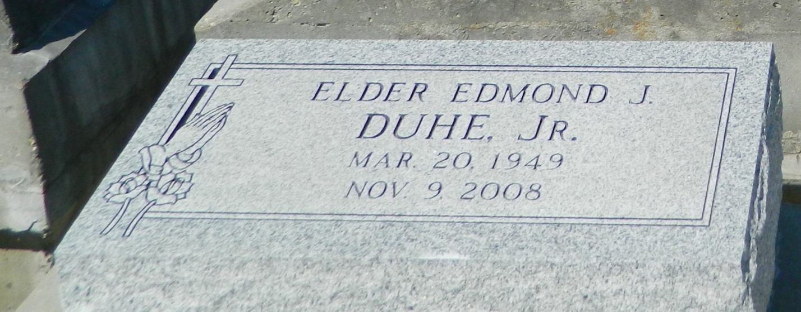

Rev. Edmond "Duke #1" Joseph Duhe Jr. of Reserve, 59, died Sunday, November 9, 2008. He was husband of Annette Robinson Duhe, son of Eva Songy Duhe and the late Edmond J. Duhe Sr. Father of David, James Robinson, Damien Bates and Jacquet Ware, stepfather of Angela Joseph-Thomas, brother of Theresa Duhe Johnson, Donna Duhe Burl and Amy Duhe Rixner. Also survived by a host of nieces, nephews and other relatives.
Relatives and friends of the family also pastor, officers and members of the New Rescue Mission Missionary B.C., Our Lady of Grace Catholic Church and neighboring churches, employees of Chester Victor Trucking Co., Sister Duhe's Daycare, Delta Coating and Damien's Flooring are invited to attend funeral services on Saturday, November 15, 2008 at noon at the New Rescue Mission Missionary B.C. at 168 E. Robinson (E. 14th St.) in Reserve. A musical tribute will be held from 11 a.m. until time of service. Rev. Joseph Smith officiating. Interment at Zion Travelers Cemetery in Reserve. Visitation at the church after 9 a.m.
L'Observateur (La Place, LA) - Friday, November 14, 2008
Contributed by Jane Edson

