Wilfred Lannie Duhe
April 17, 1935 – August 17, 2002

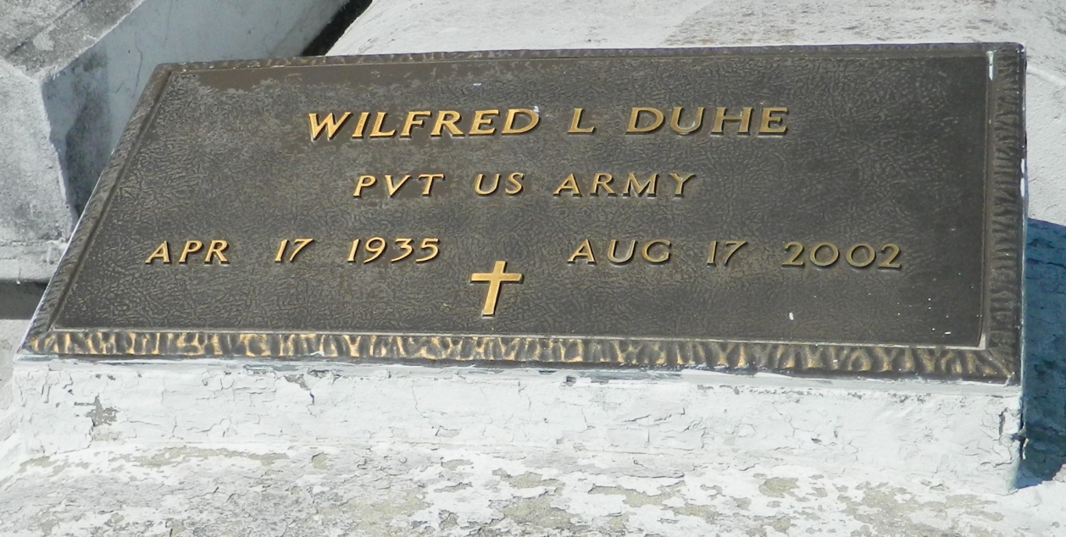

Wilfred Lannie Duhe departed this earthly life and entered into eternal rest on Saturday, August 17, 2002 at 2:35 A.M. at Veterans Affairs Medical Center of New Orleans, LA. Son of the late Irma and Beasley Duhe. Husband of Jacqueline W. Duhe of Mt. Airy, LA. Father of Janine D. Daniels, Mia D. Merrell of New Orleans, LA and Damian T. Duhe of Mt. Airy, LA. Brother of Leo Billy Duhe of Laplace, LA, Percy Duhe and Irene D. Robinson of New Orleans, LA. Grandfather of Anthony D. Merrell, Jr. and Ariane N. Bell. Also survived by a host of other relatives and friends.
A native and resident of Mt. Airy, LA.
Relatives and friends of the family also Pastors, Officers and Members of the St. Mark Baptist Church, St. John Baptist Church of Mt. Airy, LA and all neighboring churches are invited to attend the funeral. Services on Thursday August 22, 2002 at 11:00 A.M. at St. Mark Baptist Church, 132 Marquez St., Mt. Airy, LA. Dr. Oscar Nelson, Sr. Officiating. Interment in Zion Travelers Cemetery, Lions, LA. Visitation will be at the above named church from 9:00 A.M. until service time.
BARDELL'S MORTUARY of Mt. Airy, LA in charge. Information 985-535-6837

Times-Picayune, The (New Orleans, LA) - Wednesday, August 21, 2002
Contributed by Jane Edson

