Velma Earl
February 16, 1919 – February 25, 2005

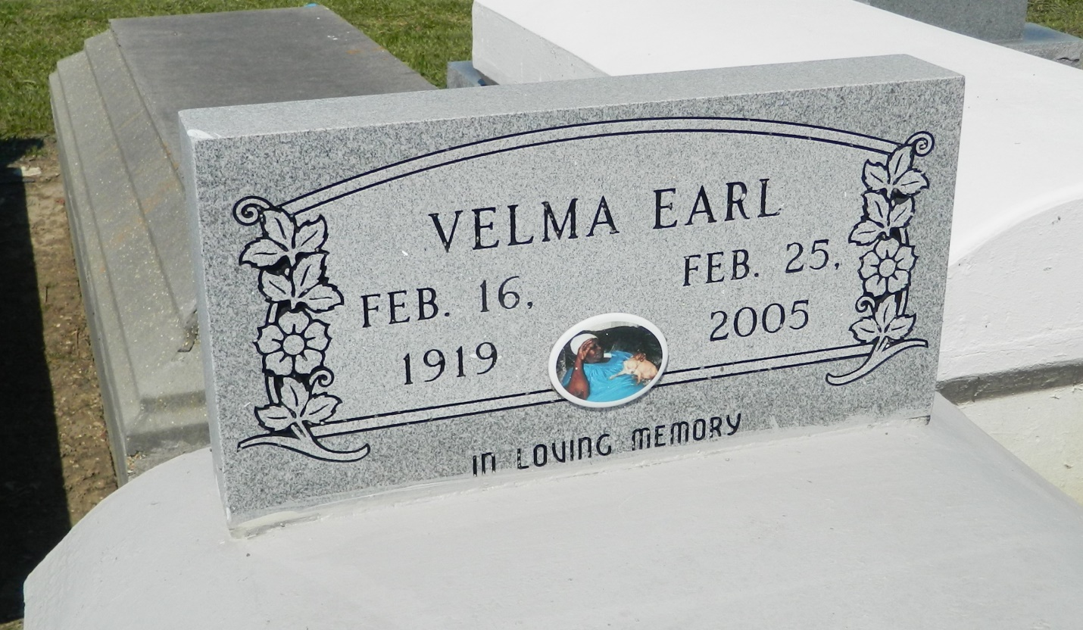

GARYVILLE - Velma Earl, 85, a resident of Lutcher, died Feb. 25. She was the mother of Timothy Fobb.
She is also survived by six grandchildren and two great-grandchildren.
Services were March 3 at New Hopeful Baptist Church, Garyville, with interment at Zion Travelers Cemetery, Lions.

L'Observateur (La Place, LA) - Monday, March 7, 2005
Contributed by Jane Edson

