Dorothy Mae (Tyler) Ellis
August 30, 1932 – August 14, 2014

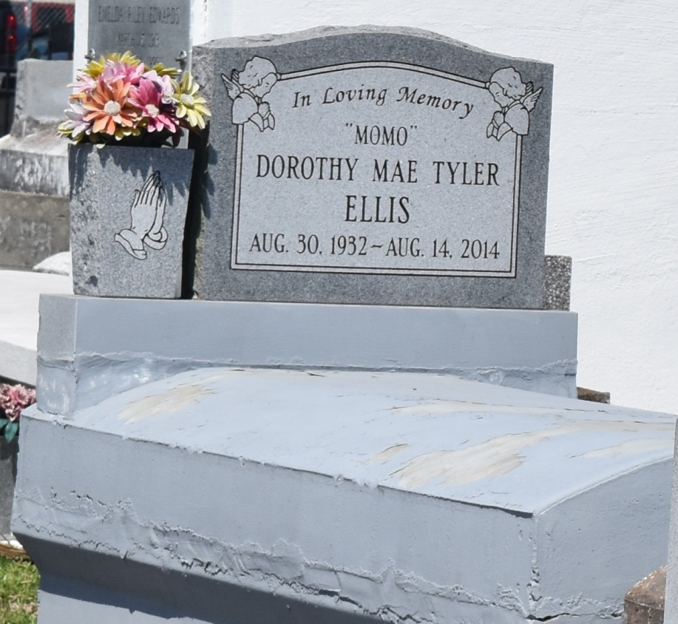

Sister Dorothy Mae (Mae-Ree) Tyler Ellis, Age 81, departed this life on Thursday August 14, 2014 in New Orleans, La. Beloved Wife by 1st marriage late Chester Reese Sr, and 2nd marriage the late Joseph Ellis, Mother of Mona Cook and Chester Reese Jr, Linda Smith, Irma (Kinley Sr) Porter, Phyllis (Mark Sr) Washington, Wanda (Elston) Johnson, Gerald (Shanikia) Ellis, and the late Alex Reese, 17 Sisters, 6 Brother, and a host of Grandchildren, Great and Great Great-grandchildren, other relatives and friends.
Home going celebration will be on Saturday August 23, 2014 at 11:00 am at Zion Travelers B. C., 713 Walnut St., Laplace, La., Rev. Julius Ellis Pastor, Interment in Church Cemetery, Reserve, La. Visitation 9 am at church.
Services Entrusted to Hobson Brown Funeral Home, 134 Daisy St. Garyville, La 70051,
985-535-2516.

Times-Picayune, The (New Orleans, LA) - Wednesday, August 20
Contributed by Jane Edson

