Mary Lee Ellis
August 11, 1954 – January 22, 1996

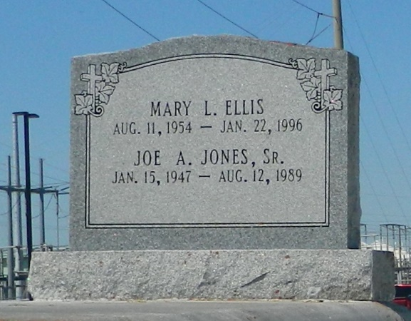

Mary Lee Ellis, a certified nursing assistant, died Monday of a heart attack at River Parishes Hospital. She was 41. Ms. Ellis was a native of Reserve and lived in LaPlace for the past two years. Survivors include a daughter, Dariana Ellis; a son, Gavin Ellis; her mother, Ora Lee Ellis; three brothers, Julius and Wilfred Ellis Sr. of LaPlace and Warren Ellis Jr. of Kansas City, Kan.; and seven sisters, Geraldine Ellis of New Orleans, Lillie Mae Jones of Portland, Ore., Sophia Adams of Gramercy, Emma Lee Morris of Reserve, and Ella Howard, Shirley Washington and Olga Smith of LaPlace. A wake will be held today at 8 p.m. at Zion Travelers Baptist Church, West 23rd Street, Reserve. A funeral will be held Monday at 11 a.m. at the church. Burial will be in Zion Travelers Cemetery. Hobson-Brown Funeral Home is in charge of arrangements.

Times-Picayune, The (New Orleans, LA) - Sunday, January 28, 1996
Contributed by Jane Edson

