Linda (Morris) Esko
September 25, 1952 – May 25, 2007

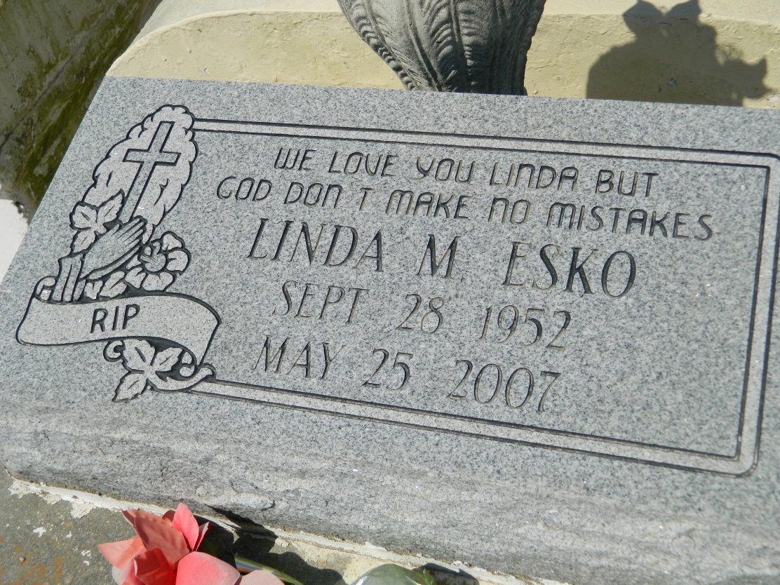

Linda Esko departed this earthly life on Friday, May 25, 2007 at Kindred Hospital of New Orleans, LA. Beloved daughter of Vivian Braxton of Mt. Airy, LA. Loving wife of Lester " Peter" Esko, Sr. of LaPlace, LA. Mother of Shannon Morris, Lester Esko, Jr., Linwood Esko all of LaPlace, LA and the late Sydonna Morris. Sister of Vergie Watkins, Horace Morris, Jr., Judy Robinson, Shelia Buyard, Georgianna Fobb, George Braxton, Jr., Bobby Braxton, the late Hilton Morris and Tim Braxton. Also survived by 8 grandchildren, aunts, uncles, nieces, nephews, other relatives and friends.
Relatives and friends of the family; also pastors, officers and members of St. Mark Baptist Church of Mt. Airy, LA and all neighboring churches are invited to attend the Funeral Services on Saturday, June 2, 2007 at 11:00 a.m. at the St. Mark Baptist Church, 132 Marquez St., Mt. Airy, LA. Rev. Oscar Nelson, Sr., officiating. Interment in Zion Travelers Cemetery of Lion, LA. Vistation will be at the above named Church from 9:00 a.m. until service time. No viewing after service.
BARDELL'S MORTUARY of Mt. Airy, LA in charge. Information: (985) 535-6837.

Times-Picayune, The (New Orleans, LA) - Friday, June 1, 2007
Contributed by Jane Edson

