Barbara Ann (Riley) Farlough
October 20, 1951 – September 1, 2015

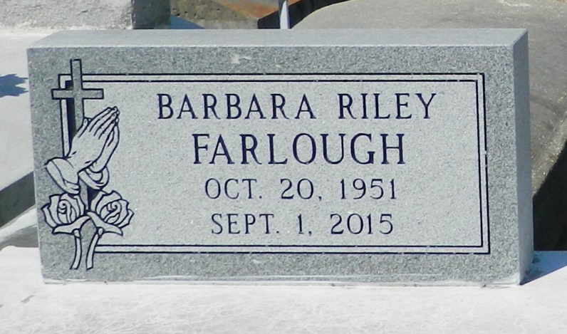

Barbara Ann Riley Farlough age 63 departed this life on Tuesday September 1, 2015. Funeral services will be on Friday September 11,2015 11:00am at St. John Missionary B. C., 287 Daffodil St., Mt Airy, La., Rev. Gary Bolden, pastor; interment in Zion Travelers Cemetery, Lyons, La. Viewing at 9am until service time (ONLY)

Times-Picayune, The (New Orleans, LA) - Wednesday, September 9, 2015
Contributed by Jane Edson

