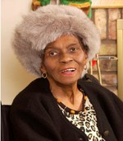
Theresa (Jones) Felton
December 14, 1925 – July 2018

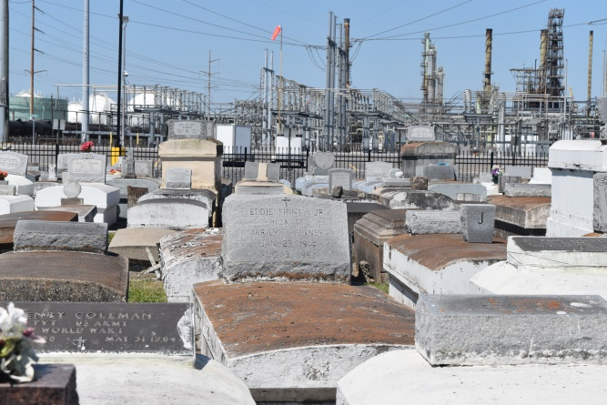

Theresa Jones Felton was born on December 14, 1925 to the late Sam and Ernestine Jones. She accepted Christ as her Lord and Savior and was baptized by Rev. A.J. Favors in the Mississippi River at about age 13 or 14. Theresa united with True Light Baptist Church of Garyville, LA under the leadership of Pastor Favors. She loved the Lord and attended church faithfully. She later in life moved to Bossier City, LA and attended Harvest Temple Church of God in Christ. Her favorite scripture was Psalm 23 and she loved Matthew 6:9-13. "This, then, is how you should pray: "Our Father in heaven, hallowed be your name. Give us today our daily bread. And forgive us our debts, as we also have forgiven our debtors. And lead us not into temptation but deliver us from the evil one." In 1943, she married Adolph Causey and to this union one son was born, David Causey, who preceded her in death while deployed in Vietnam. Later, she married Rev. Ulyses Felton and to this union seven children were born: Margaret, Shermon, Valrina, Ulyses Jr., Joyce, Lois and Juanita. Theresa attended Southern University in Baton Rouge and was a gracious and devoted substitute teacher at Sixth Ward Elementary School for many years. She enjoyed life, loved to travel, and enjoyed the love of her children, grandchildren and great grandchildren.
She leaves to mourn, children: Margaret Felton Johnson (Michael), Shermon Felton (Margaret “Peggy"), Valrina and Ulyses Felton Jr., and Juanita Felton Bridges along with a host of grandchildren, great grandchildren, nieces, nephews, cousins and friends. She was preceded in death by her husband, Rev. Ulyses Felton, Sr. and three children; PFC David Causey, Lois Felton Torregano, and Joyce Felton Joseph. Mrs. Theresa will be truly missed by all of those whose lives she touched with a friendly smile, a word of encouragement, a helping hand, and in whatever way she could to honor her Father in Heaven.
Funeral services will be held on Saturday, July 28, 2018 for 11:00am from True Light Baptist Church, 258 S. Little Hope Street., Garyville, LA. Rev. Wesley Anderson Sr., Pastor; Pastor Ted Lamont Scott, Harvest Temple COGIC, officiant. Viewing 10:00am. Interment Zion Travelers Church Cemetery, Reserve, LA.
Her final care has been entrusted to Treasures of Life Funeral Services, 315 E. Airline Hwy, Gramercy, LA 70052. 225-258-4039.
“When someone you love becomes a memory, that memory becomes a TREASURE!”
www.treasurefunerals.com (accessed 10/7/2018)

