Rev. Ulyses Felton Sr.
December 2, 1925 – May 11, 2007

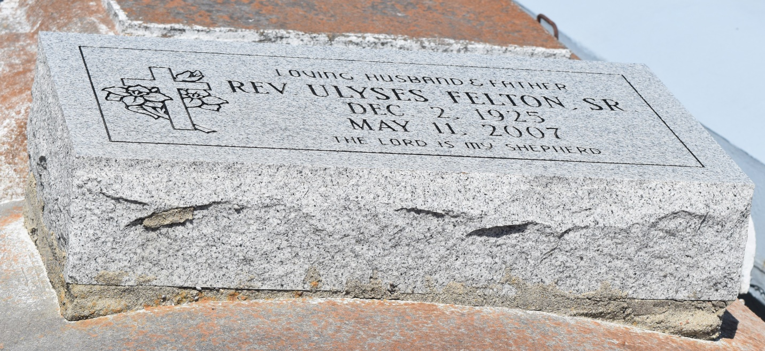

Rev. Ulyses Felton, Sr. went home to be with his Lord and Savior Jesus Christ at 4:00 AM on May 11th, 2007. He was the proud and faithful husband of Mrs. Theresa Jones Felton; the father of PFC David Causey, Margaret Felton Johnson, Sherman Felton, Valrenia Felton, Ulysses Felton, Jr; Joyce Felton Joseph, the late Lois Felton Terrogano, and Juanita Felton Bridges. Rev. Felton will be truly missed by all of those whose lives he has touched with a friendly smile, a word of encouragement, a helping hand, or an anointed word from God.
Funeral services will be at New Hopeful Missionary Baptist Church, Garyville, Louisiana, Dr. Roland J. Morgan, Sr., Pastor, on May 19, 2007 at 11 a.m. He will be laid to rest at Mt. Zion Cemetery, Reserve, Louisiana.
Baloney Funeral Home, Garyville, Louisiana presiding.

Times-Picayune, The (New Orleans, LA) - Friday, May 18, 2007
Contributed by Jane Edson

