Kevin Pablo Ferrygood
May 14, 1988 – January 14, 2012

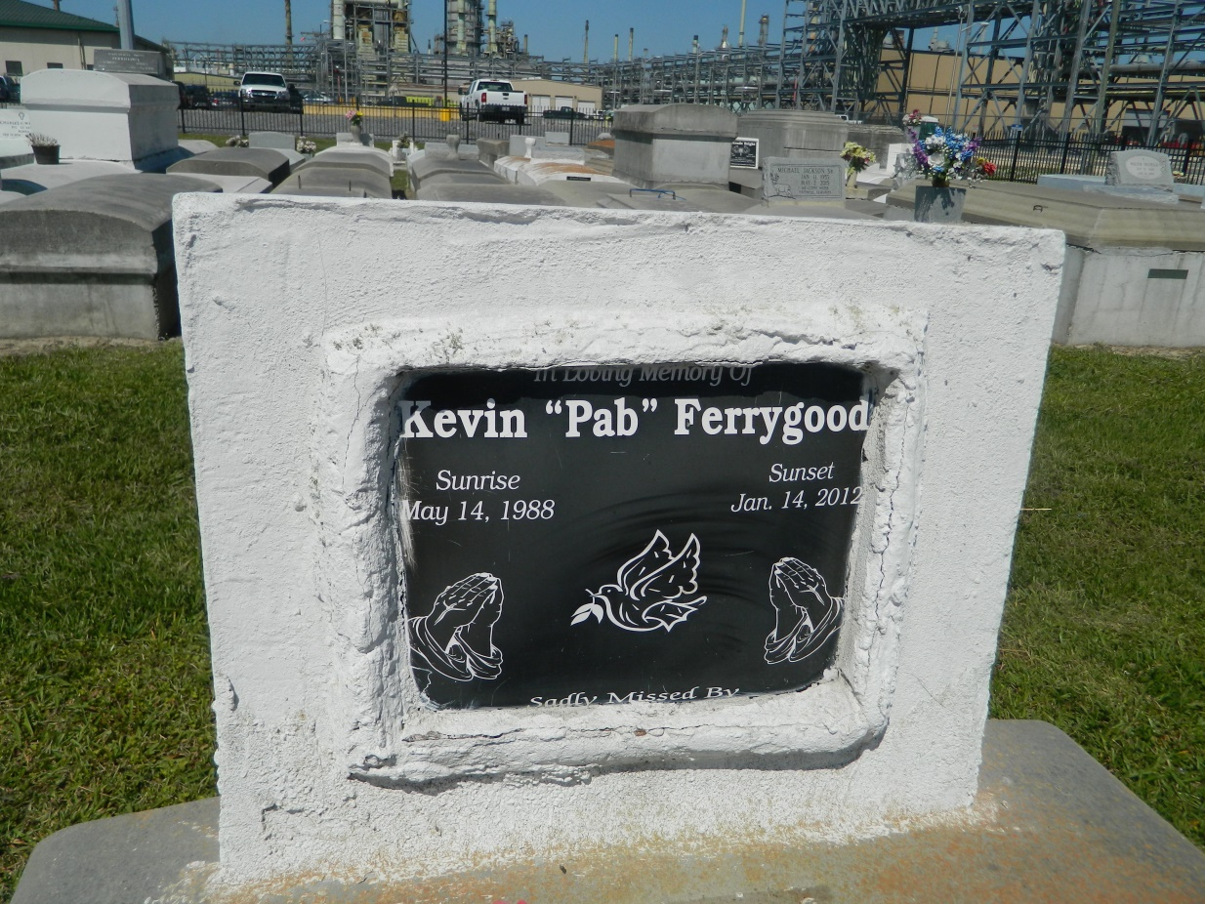

Kevin Pablo Ferrygood passed away on Saturday, January 14, 2012 in Garyville, LA at the age of 23. Son of Shenita Ferrygood and the late Kevin Pidgeon. Father of Kevianna and Kevin. Survived by 3 sisters, 8 brothers. Reared by the late Robert and Lillie Pidgeon. He is survived by a host of aunts, uncles, other relatives and friends.
Services are Saturday, January 21, 2012 at 11am at New Wine Church in Laplace, LA. Officiated by Rev. Neil Bernard. Interment Zion Travelers in Lions, LA. Visitation from 9 until service.
Funeral service entrusted to The Baloney Funeral Home, LLC, 399 Earl Baloney St., Garyville, LA, 985-535-2540. Condolences can be expressed at www.baloneyfuneralhome.com.

Times-Picayune, The (New Orleans, LA) - Friday, January 20, 2012
Contributed by Jane Edson

