Jeremy J. Fleming
May 14, 1987 – June 3, 2012

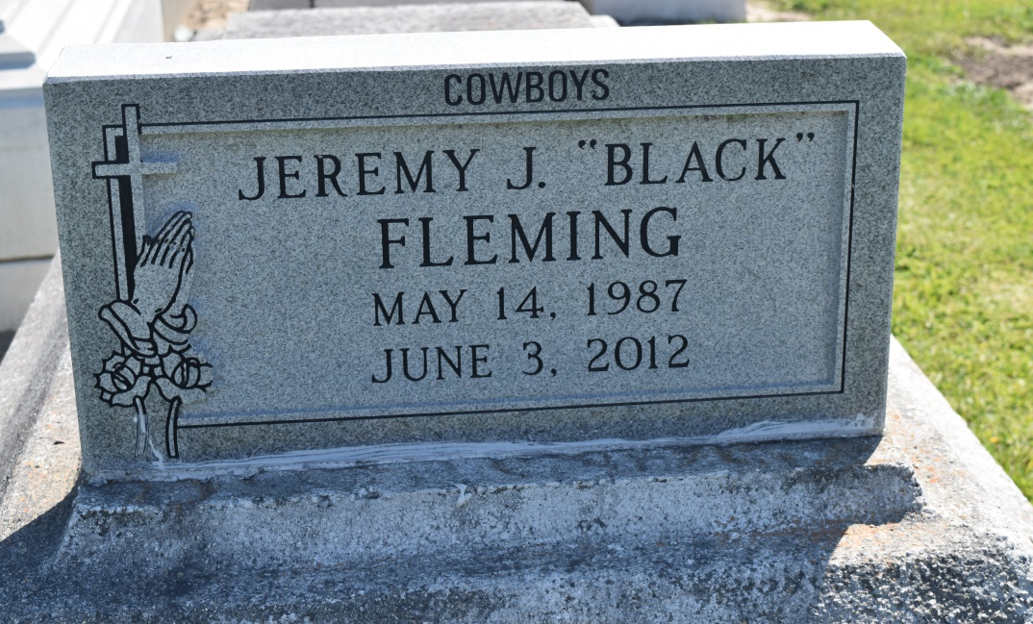

A Reserve man was killed in a head-on collision early Sunday morning in St. Charles Parish, according to Louisiana State Police.
Jeremy Fleming, 25, was killed when the Infinity Q45 he was driving was hit by a Chevrolet pickup truck traveling in the wrong direction.
The crash occurred shortly before 3 a.m. on U.S. 61 near Apple Street.
Police said the pickup that was traveling north in the southbound lanes is believed to have been driven by Manuel Castro, 32, of Livingston. Police said Castro, who was transported to the hospital with moderate injuries, made statements at the scene that left it unclear whether he was the driver.
Fleming died at the scene. A passenger in the Infinity, a 25-year-old Garyville man, was transported to the hospital with moderate injuries. None of the people involved in the crash was wearing a seat belt, police said.
Police said the pickup will be processed for DNA evidence by the crime lab.
A toxicology analysis on Castro's blood is pending. The crash remains under investigation, and criminal charges may result, police said.

Times-Picayune, The (New Orleans, LA) - Monday, June 4, 2012
Contributed by Jane Edson

