Josephine (Taylor) Fobb
March 19, 1950 – May 25, 2006

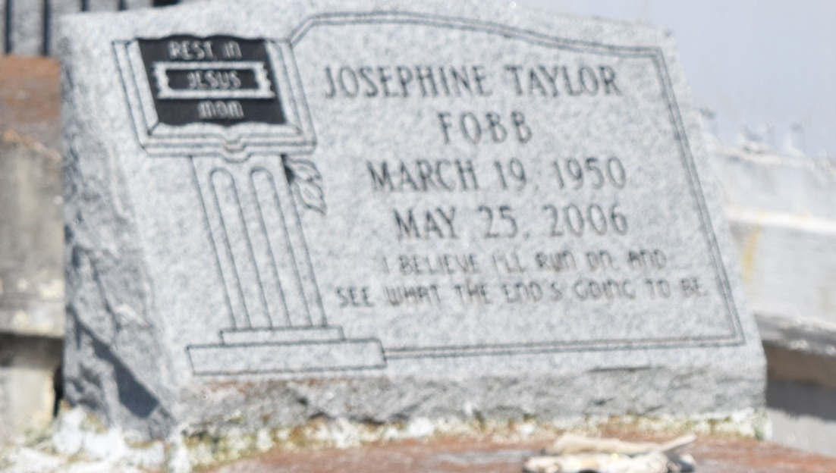

Josephine T. Fobb, an employee of the Hilton New Orleans Airport Hotel, departed this life on Thursday, May 25, 2006 at River Parishes Hospital, LaPlace, La., Daughter of Mable Taylor, and the late of Herman Deroncelay. Wife of Larry Fobb, Sr. Mother of Larry Jr., Courtney and Achanta Fobb. Sister of Kelly, and Irene Taylor, Elnora Freeman, Dora Belvin, Joyce Gautreaux, and Audrey Snyder. Mother-in-law of Anedra Fobb. Daughter-in-law of Mr. and Mrs. Herfert Fobb. Also survived by 1 grandchild: Ryan Fobb, and a host of nieces, nephews, cousins, sisters and brothers-in-law, other relatives and friends. Age 56.
Relatives and friends of the family, pastor, officers, and members of Rising Star Baptist Church and all neighboring churches, employees of the Hilton New Orleans Airport Hotel, Pepsi, the Huddle House, St. John Parish School Board are invited to attend the funeral service on Thursday, June 1, 2006 at 11:00 a.m. from Rising Star Baptist Church, 620 Cardinal Street, LaPlace, La., Reverend Donald Ray August, Sr., Pastor, officiating. Interment in Zion Travelers Cemetery, Reserve, La. Visitation from 5 p.m. to 7 p.m. on Wednesday at Hobson Brown Funeral Home, 134 Daisy Street, Garyville, La and on Thursday from 9:00 a.m. until service time at the church
Service entrusted to: HOBSON BROWN FUNERAL HOME, GARYVILLE, LA

Times-Picayune, The (New Orleans, LA) - Wednesday, May 31, 2006
Contributed by Jane Edson

