Lillie Mae (Smith) Fobb
Abt. 1943 – June 13, 2019

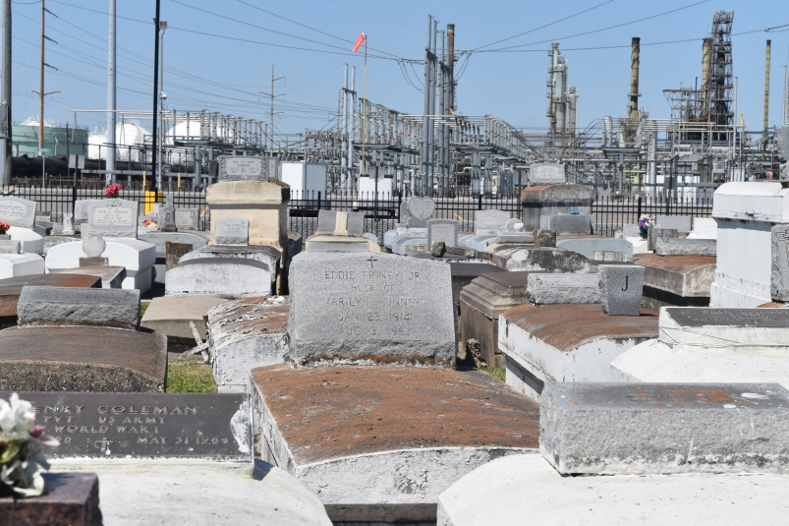

Lillie Mae Smith "Lil" Fobb at the age of 76yrs. departed this earthly life and entered into eternal rest on Thursday June 13, 2019 at her daughters home in LaPlace, La surrounded by her family. Beloved wife of the late George Fobb Sr. Daughter of the late Hazel Nicholas and Roger Smith Sr. Loving mother of Ursula Fobb, Stephanie Fobb Moore, George Fobb Jr., and Micah Fobb. Sister of Clarence Smith. Also survived by 15 grandchildren, 14 great-grandchildren, and a host of nieces, nephews other relatives and friends. Lil was preceded in death by her husband George Fobb Sr., her parents Hazel Nicholas and Roger Smith Sr., Grandson Tramaine J. Anderson, Siblings: Roger Smith Jr., Ivory Joe Smith, Raymond Scott, and Audrey Breaux. Pastors, Officers and Members of True Light Baptist Church of Garyville, La and all neighboring churches are invited to attend the Home going Celebration on Saturday June 22, 2019 at 11:00 am at True Light Baptist Church 258 Little Hope St. Garyville, La. where the Pastor is Rev. Wesley Anderson Sr.; Rev. Sam Jones III officiating. Interment is in Zion Travelers Cemetery in Lions,La. Visitation will be on Friday June 21, 2019 at Bardell's Mortuary 3856 Hwy. 44 Mount Airy, La from 3:00pm until 5:00pm and on Saturday at True Light Baptist Church of Garyville,La. from 10:00am until service time. Bardell's Mortuary of Mt. Airy, La. in charge. Information: 985-535-6837.

Bardell’s Mortuary, Mt. Airy, LA; accessed 7/8/2019

