Calvin Foster
June 8, 1946 – June 12, 2025

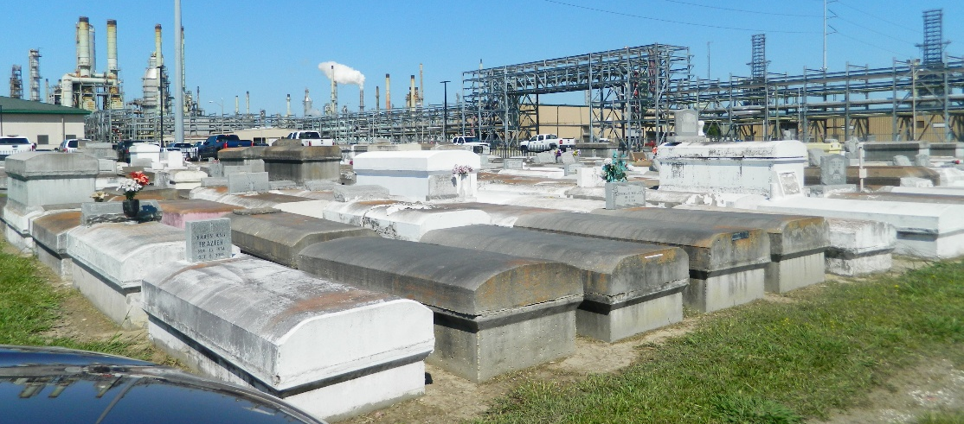

Calvin (Shoop, Sho-Pop) Foster, age 79, the sixth child born to Thomas Sr., and Viola Smith Foster, on June 8, 1946, at Charity Hospital in New Orleans, Louisiana. He attended Reserve Rosenwald Elementary School, and graduated from Fifth Ward High School in Reserve Louisiana. Calvin was a life-long member of the Zion Travelers Missionary Church, baptized by his Pastor, Rev. Marshall Cambre Sr. He was an active member who responded to the call wherever help was needed. He sang in the adult choir and male chorus. He faithfully attended Bible class on Wednesday nights and choir rehearsals as scheduled. He was the graveyard maintenance person for the church. If someone wanted to know the location of his or her loved one’s grave, he knew exactly where to find it. He was a one-man Cemetery Committee, the Special Man.
Growing up in a close knit family oriented community of Dog Town, (Lions), he was shaped by strong spiritual values with his siblings, Beatrice Foster-Jackson, Thomas Foster Jr., Clarence Foster, Ervin Foster, Albert Foster, Alton Foster, Patricia Foster-Nicholas, Shelia Foster, and Norma Jean Foster-Lilly. FAREWELL FOR NOW DEAR BROTHER.
Preceded in death by parents, Thomas and Viola Smith-Foster, brothers, Thomas Jr., Albert, and Alton Foster, Niece Shelia M. Foster, Sisters –in-love, Elaine Albert Foster, Katherine King-Foster, and Loucrecia Johnson Foster. Calvin (Shoop, Sho-Pop) Foster You have left behind a Legacy that is rooted in Love, Joy, and Strength, that will forever live on in the Hearts of the “FOSTER CREW”
A Celebration of Life, Love, and Legacy is being held on Saturday, June 21, 2025 at the Zion Travelers Missionary Baptist Church, 713 Walnut Street, LaPlace Louisiana 70068.Visitation begins for 9:00 a.m. followed by 11:00 a.m. service. Rev. Julius Ellis Sr., Senior Pastor Officiating. Interment Zion Travelers Missionary Baptist Church Cemetery (Marathon).

Treasures of Life Funeral Service, Gramercy, Louisiana
June 26, 2025

