Loucrecia (Johnson) Foster
June 8, 1937 – March 11, 2015

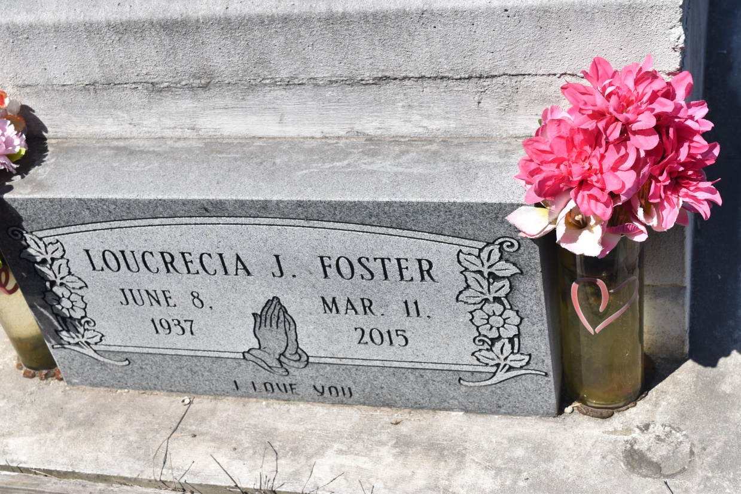

Loucrecia Johnson Foster, passed away Wednesday, March 11, 2015, at the age of 77 years old. Daughter of the late Pearl Harris and Ernest Johnson. Beloved wife of Clarence Foster, Sr. Father of Clarence (Peggy) Foster, Jr., David Foster, Bryant (Margo) Foster, Uchenna Williams and the late Daniel Foster. Also survived by a host of sisters, brothers, grandchildren, nieces, nephews, cousins, other relatives and friends.
Funeral services will be held at Zion Travelers Baptist Church, 713 Walnut Street, Laplace, La. on Saturday, March 14, 2015 for 1:00 p.m. Visitation will be from 9:00 a.m. until time of service. Interment will be at Zion Travelers Cemetery, Lions, La. Rev. Julius Ellis will be officiating. A viewing will be held on Friday, March 13, 2015, from 2:00 p.m. until 5:00 p.m. at The Baloney Funeral Home, LLC. Care of my wife was entrusted to The Baloney Funeral Home, LLC, 1905 W. Airline Highway, Laplace, La., 985-224-8460. Condolences can be expressed at www.baloneyfuneralhome.com.

Times-Picayune, The (New Orleans, LA) - Friday, March 13, 2015
Contributed by Jane Edson

