Thomas Foster Sr.
March 27, 1905 – October 31, 2004

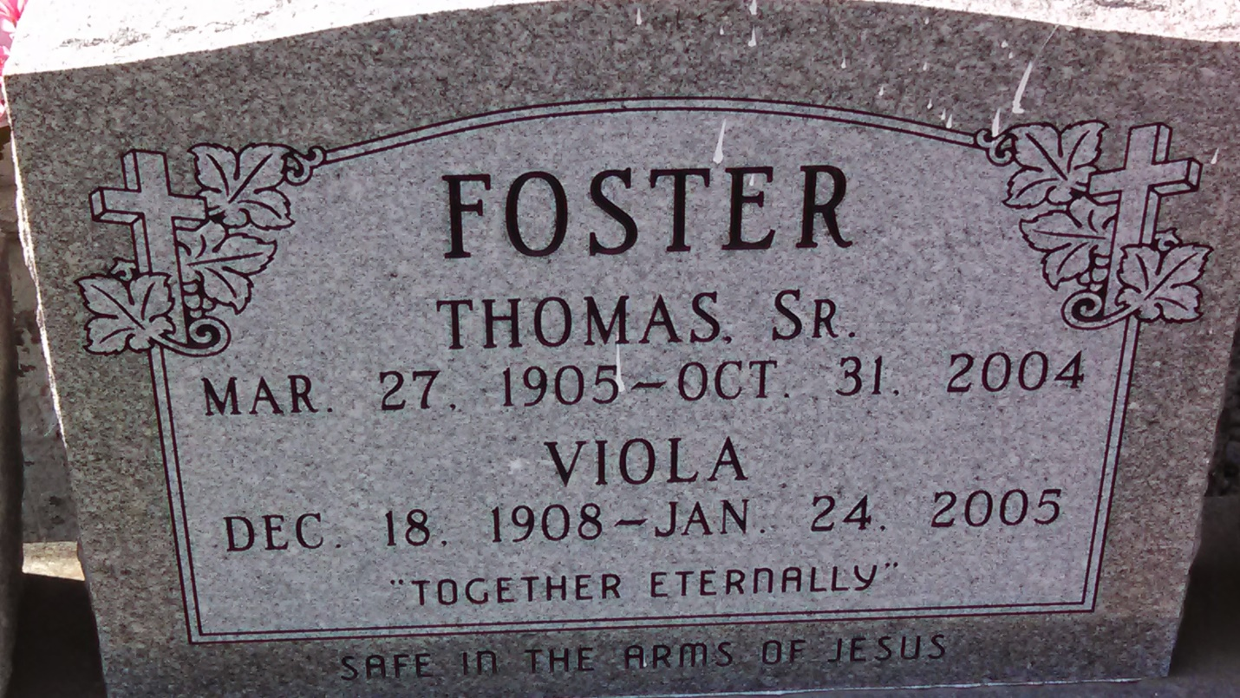
Photo by GeniHound

Thomas Foster Sr., a retired employee of Illinois Central Railroad, died Sunday at River Parishes Hospital. He was 99. Mr. Foster was a lifelong resident of the Lions area of Reserve. He was a member of Zion Travelers Baptist Church, where he had served as Sunday school superintendent and as a deacon. Survivors include his wife, Viola Smith Foster; four daughters, Beatrice F. Jackson, Patricia Nicholas, Shelia Foster and Norma Jean Lilly; five sons, Clarence, Ervin, Albert, Calvin and Alton Foster; 15 grandchildren; 23 great-grandchildren; and five great-great-grandchildren.

A funeral will be held Saturday at 11 a.m. at Zion Travelers Baptist Church, West 23rd St., Reserve. Visitation will begin at 9 a.m. Burial will be in the church cemetery.

D.W. Rhodes Funeral Home handled arrangements.

Times-Picayune, The (New Orleans, LA) - Friday, November 5, 2004
Contributed by Jane Edson

