Viola (Smith) Foster
December 18, 1908 – January 24, 2005

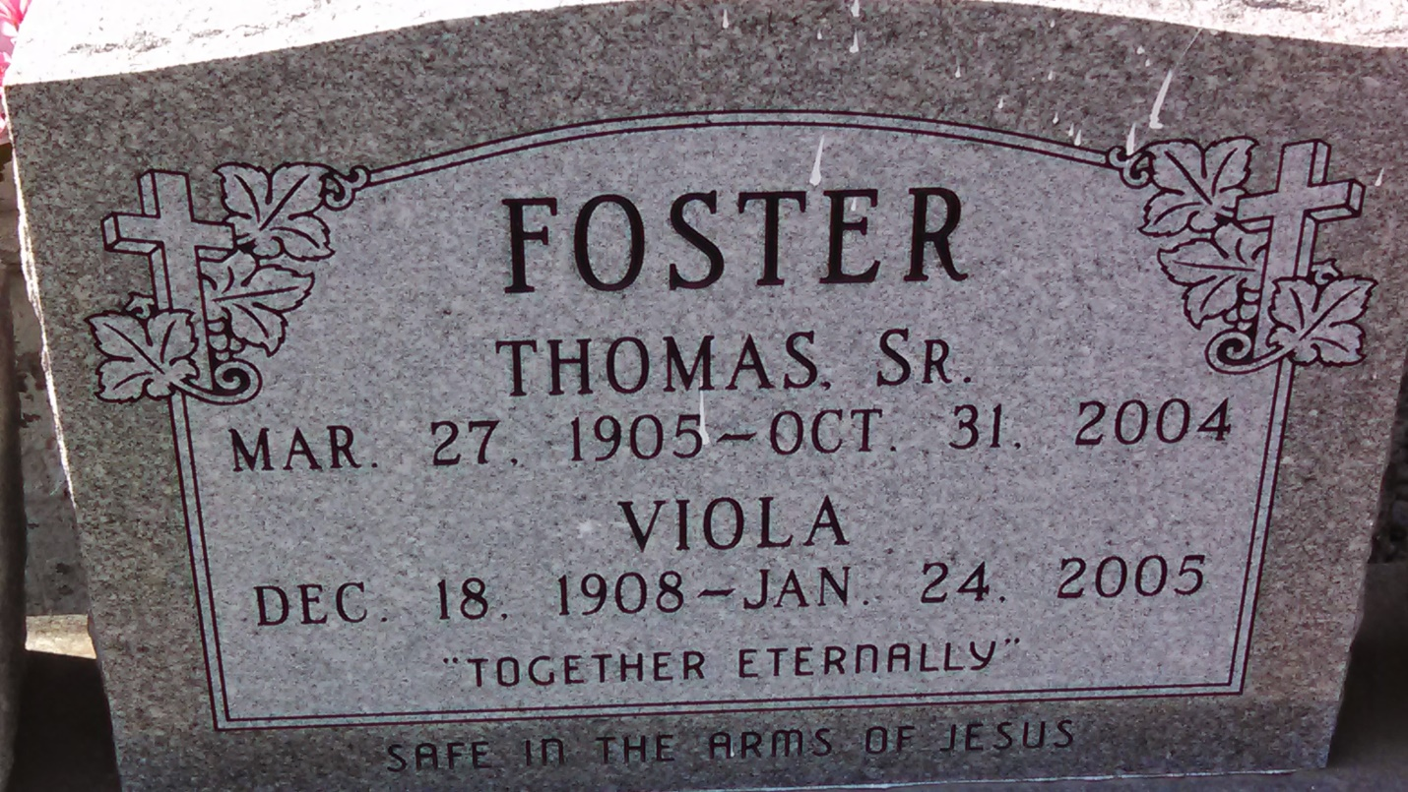
Photo by GeniHound

Viola Smith Foster, a homemaker, died Jan. 24 at River Parishes Hospital. She was 96. Mrs. Foster was born in Garyville and lived in Reserve. Survivors include four daughters, Beatrice F. Jackson, Patricia Nicholas, Shelia Foster and Norma Jean Lilly; five sons, Clarence, Ervin, Albert, Calvin and Alton Foster; 15 grandchildren; 26 great-grandchildren; and five great-great-grandchildren.
A funeral will be held Saturday at 11 a.m. at Zion Travelers Baptist Church on West 23rd Street in Reserve. Visitation will begin at 9:30 a.m. Burial will be in the church cemetery.
The Baloney Funeral Home is in charge of arrangements.
Times-Picayune, The (New Orleans, LA) - Friday, January 28, 2005
Contributed by Jane Edson

