Cheryl P. Frank
September 21, 1945 – October 23, 2011

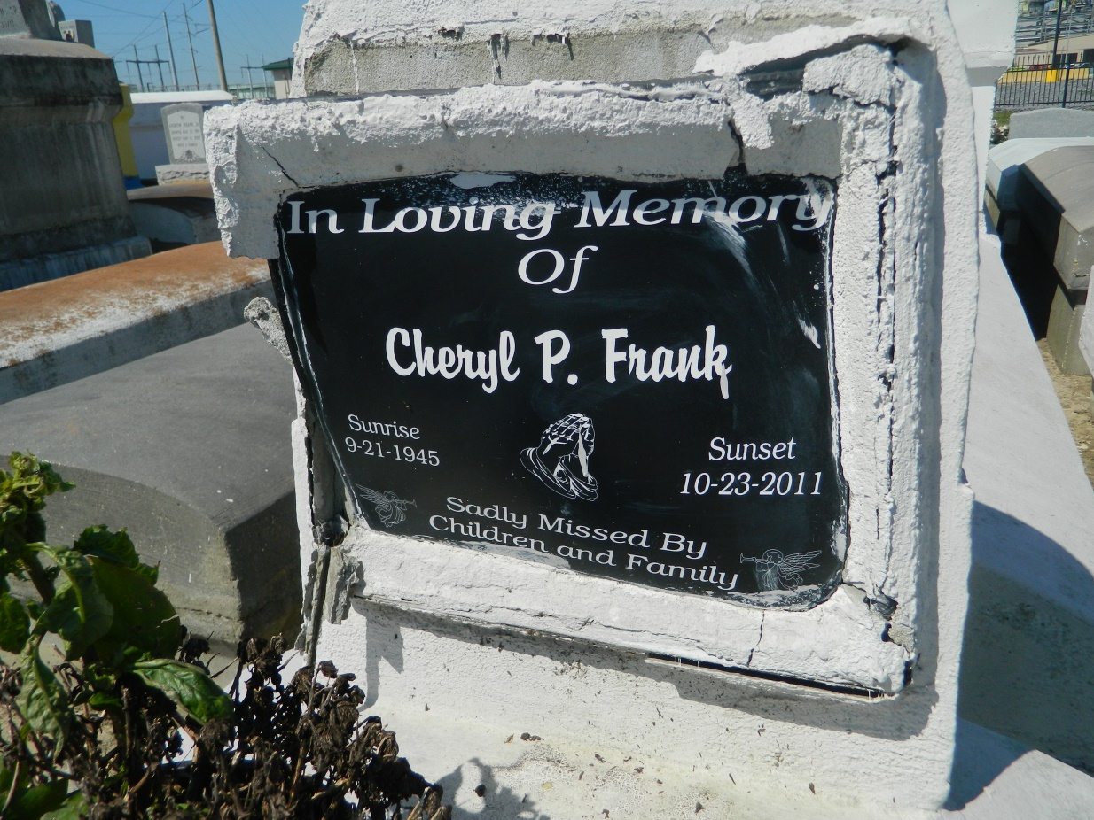

Cheryl P. Frank, age 66, passed away on Sunday, October 23, 2011 in River Ridge, La. She is survived by her husband Raymond Frank, Sr., children: Raymond Jr., Randy, and Twala Frank, Darlene Horace, Paula Russell, and Laqutta Lewis, 4 sisters, 7 brothers, 15 grandchildren, and 6 great-grand-children.
Service will be held on Friday, October 28, 2011 at Tchoupitoulas Chapel, Hwy 44, Reserve, La., at 10.00 a.m. Rev. Murphy Pastor. Visitation at 8:00a.m. Interment in Zion Travelers Cemetery Reserve La.
Service Entrusted to Hobson Brown Funeral Home, 134 Daisy St. Garyville, La., 70051,
(985) 535-2516.

Times-Picayune, The (New Orleans, LA) - Thursday, October 27, 2011
Contributed by Jane Edson

