George Gardner
October 30, 1955 – December 16, 2007

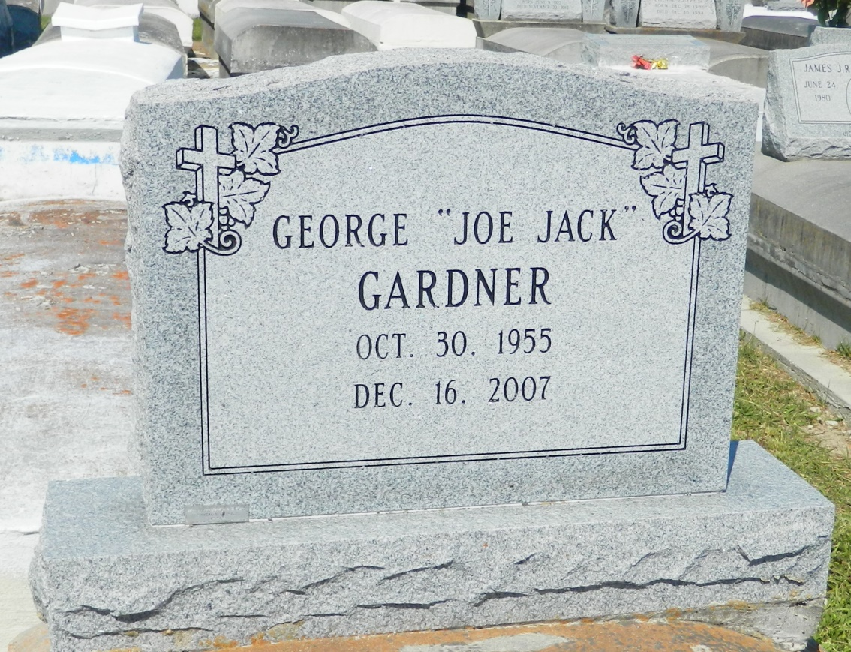

George "Joe Jack" Gardner at Leonard J. Chabert Medical Center, in Houma, La., passed away on Sunday, December 16, 2007. Age 52. Son of the late Robert and Lillian (Miles) Gardner. Husband of Beverly Walker Gardner. Father of Calvin Gardner, Delisa Gardner (Ruenell), and Kawan Gardner (Kreshanna). Also survived by 3 sisters, 4 brothers, 7 grandchildren, aunts, sisters and brothers in law, cousins, and friends. A native of Garyville and resident of Reserve, La.
Pastor, Officers and Members of Providence B.C, #2, New Hopeful B.C., and Mt. Zion B.C. #2, and all neighboring churches; employees of Zapps Potato Chip, Hilton Hotel, Colonial Sugar and Hertz Rentals are invited to attend the funeral service on Saturday, December 22, 2007 at 11:00a.m. from Providence B.C. #2152 Union Lane, Montz, La., Rev. Donald Brown, Sr., Officiating. Interment in Zion Travelers Cem., Reserve, La. Visitation on Saturday at the church from 10:00a.m. until Service time.
Service Entrusted to Hobson Brown Funeral Home, Garyville, La, 985-535-2516

Times-Picayune, The (New Orleans, LA) - Friday, December 21, 2007
Contributed by Jane Edson

