Larry T. Gauff Jr.
April 19, 1961 – June 30, 2002

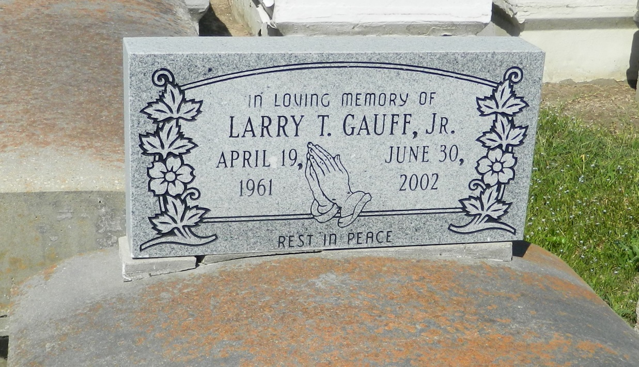

Larry T. Gauff, Jr. of Garyville, LA. at his residence on Sunday, June 30, 2002. Beloved son of Joyce Telfair Lewis and the late Larry Gauff, Sr. Brother of Deborah Gauff, Eric Gauff, Ledenia Gauff, Lenord Gauff, Kim Gauff, Deatrice Gauff, Yolanda Joseph, Renaldo Lewis, Timothy and Raven Lewis. Step-brother of Leslie Gauff and Kerry Magee. Grandson of Alberta Williams and the late Isiah Telfair and Lucien and Velma Gauff, Sr. Also survived by a host of nieces, nephews, aunts, uncles, cousins, and friends. Brother-in-law of Gaynell Gauff and Wayne Joseph. A native and resident of Garyville, LA. Age 41 years.
Relatives and friends of the family, also pastor, officers and members of the St. Mark Baptist Church and neighboring churches. Employees of St. John Parish School System, East Jefferson Hospital, Chateau Living Center, Walgreens-Laplace, St. John Parish Council are invited to attend the funeral services on Saturday, July 6, 2002 at 10:00 a.m. from the St. Mark Baptist Church, Mt. Airy, LA., Rev. Oscar Nelson, officiating. Interment Zion Travelers Cemetery, Reserve, LA.
Visitation on Friday after 4:00 p.m. at the Baloney Funeral Home, 399 Earl Baloney Dr., Garyville, LA and on Saturday after 8:00 a.m. at the church.
THE BALONEY FUNERAL HOME in charge of arrangements.

Times-Picayune, The (New Orleans, LA) - Friday, July 5, 2002
Contributed by Jane Edson

