Geniva (Dent) Hill
September 11, 1934 – August 27, 2010

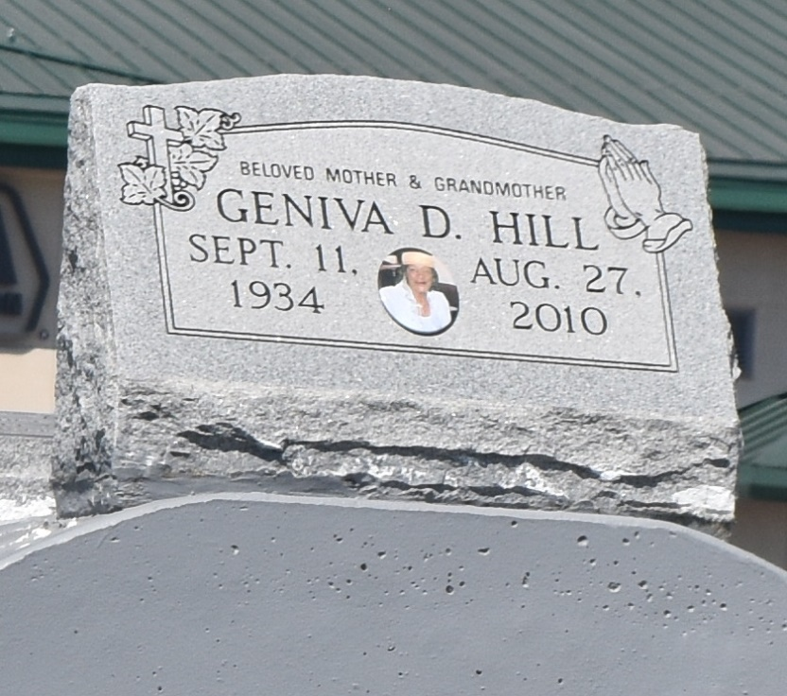

Genevia Dent Hill departed this earthly life on Friday, August 27, 2010 at 6:25a.m. at her home in Mt. Airy, La. Daughter of the late Henrietta Shade Robinson and Burns Dent and she was reared by James Robinson, Sr. Wife of the late Herman (Slim) Hill Sr. Mother of Irene S. Burl, Doretha Gardner, Katherine Williams, Donald Ray, Sr., and Lisa Jones, Allen and, Johnny Snyder, and a devoted Granddaughter whom she reared Chanda Snyder, 2 daughters in law Julie Snyder and Gwendolyn Jones. Sister of Florence R. Jones and Emily Thompson, and the late Joe Dent, Doretha Rixner, Leona Mitchell, Dotsy Robinson, Rev. James Robinson Sr., and Orelia Wood Fork. Also survived by 29 grandchildren, 43 great grandchildren, host of nieces, nephews, cousins and friends. A native and resident of Mt. Airy, La. Age 75.
Pastor, Officers, Members of St. Mark B.C. and St. John B.C. and all neighboring churches, employees of St. John Parish Schools, St. John Parish Council, Leon Godchaux, Healing Hands Staffing, Eagan Home Health Services, and Laplace Medical Center are invited to attend the Home going service on Wednesday, September 1, 2010 at St. Mark B.C., 132 Marquez St., Mt. Airy, LA. Rev. Oscar Nelson Pastor officiating. Visitation on Tuesday at the funeral home and on Wednesday from 8a.m. until 10:55 ONLY. Interment in Zion Travelers Cemetery, Reserve, La.
Professional Service Entrusted to Hobson Brown Funeral Home, Garyville, La 70051,
985-535-2516. Assisted by Michael Peterson and New Orleans Embalmer's Association

Times-Picayune, The (New Orleans, LA) - Tuesday, August 31, 2010
Contributed by Jane Edson

