Eunice (Tassin) Jackson
January 3, 1945 – November 12, 2008

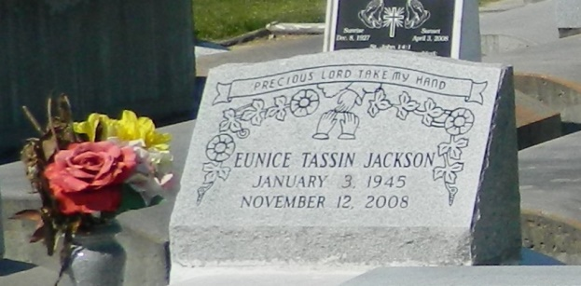

Eunice Tassin Jackson, age 63, departed this life on Wednesday, November 12, 2008 in Seattle, WA. Wife of Howard Jackson Sr. for 43 years. Mother and mother-in-law of Anthony and Howard (Felicia) Jackson, Jr. and Monica (William) Osborn. Sister of Marguerite Boutte. Also survived by 11 grandchildren: Ashley, Alexis, Satia, Howard, Ayanna, William, Keshaun, Sasha, Solana, William IV and Ta'Yanna Jackson, and a host of nieces, nephews, cousins, and friends. A native of Mt. Airy, La. and resident of Seattle, Washington for many years.
Pastors, officers and members of St. Mark B.C. and all neighboring churches are invited to the Funeral Service on Friday, November 21, 2008 at 12:00 noon at the above named church, 132 Marigold St., Mt. Airy, La. Rev. Oscar Nelson, Pastor, Officiating. Interment in Zion Travelers Cemetery, Reserve, La. Viewing at the church from 9:00 a.m. until service time. (ONLY)

Service entrusted to Hobson Brown Funeral Home, Garyville, La., (985) 535-2516

Times-Picayune, The (New Orleans, LA) - Thursday, November 20, 2008
Contributed by Jane Edson

