Michael Jackson Sr.
January 11, 1955 – May 2, 2015

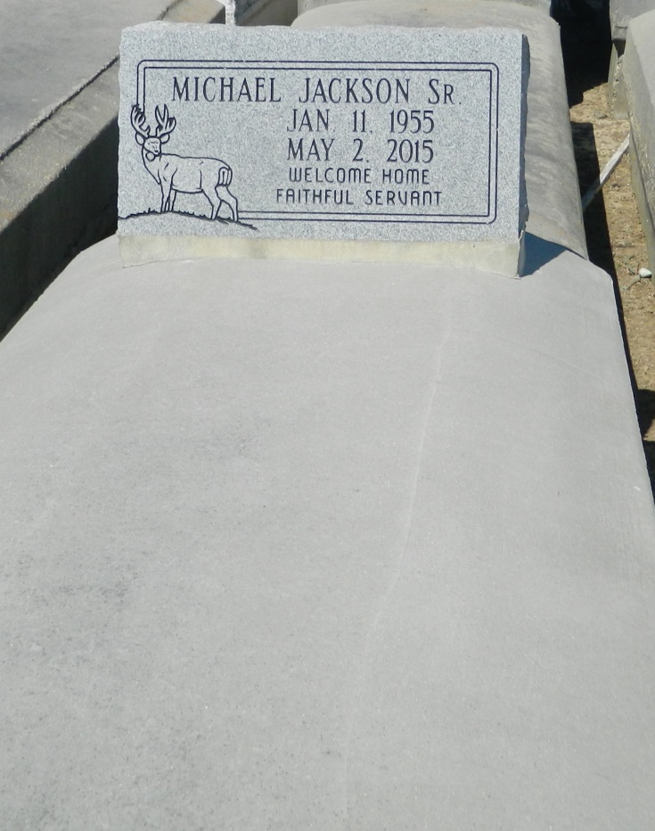

Michael Jackson Sr., age 60, transitioned into eternal rest Saturday, May 2, 2015 at Ochsner Hospital. He was the devoted husband of Betty Jean Lewis Jackson. Loving father, right hand man and best friend of Michael Jackson Jr. (Erica). Dedicated grandfather of Miya J. Jackson. Brother of Edward Baker (Mary), Jeannette Jackson (Galen), Ruth Ann Smith, Anthony Morgan (Crystal), Jerome Frazier, Kim Frazier, Jackie Frazier, Zina Francis (Johnell), Carl Pittman (Lisa), and the late Lee Duhe (Brenda), Karen Franklin, and Regina Frazier. He is preceded in death by his parents, Richard Jackson and Rosetta Smith. Relatives and friends of St. John the Baptist Parish, Luling Living Center, TSA, Entergy, St. Mark Baptist Church, Second African Baptist Church, Evergreen Baptist Church, neighboring churches and Leon Godchaux Class of 1974 are invited to attend the home going service at St. Mark Baptist Church,132 Marquez St., Friday May 8, 2015. Pastor Oscar Nelson officiating. Visitation will begin at 8:00 am until service time, 10:00 am. Interment in Zion Travelers Cemetery. Arrangements by Bardell's Mortuary. Information: 985-535-6837.

Times-Picayune, The (New Orleans, LA) - Wednesday, May 6, 2015
Contributed by Jane Edson

