Richard Jackson Jr.
September 9, 1934 – August 17, 2007

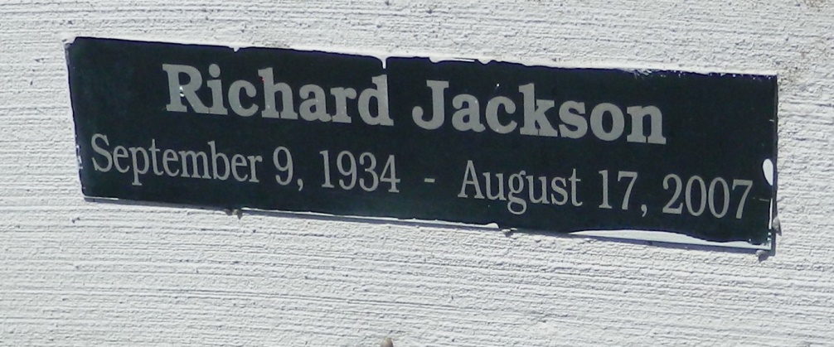

Richard (June) Jackson, Jr. of Reserve, La. on Friday, August 17, 2007 at River Parishes Hospital, LaPlace,La. Son of the late Richard Jackson, Sr. and Hazel LaGrange. Husband of Gladys Johnson Jackson. Father of Jeanette Jackson (Graylon), Michael Jackson (Betty), Khalid Jackson, Stepfather of Leon Potts, Jr. (Gwen), Troy Potts, Rachel Campbell (Troy), Guardian of Daylon Potts. Brother of Audrey Weston, Hazel Franklin (Jerome) and the late Lillie Tollerson, William, Wallace and Leon Chaney. Nephew of Louise Jackson and A.J. Ealy. Devoted cousin of Leola Joseph. Best friend of Adrain Claudette and Lawrence Taylor. Also survived by a host of grandchildren, great grandchildren, nieces, nephews, sisters and brothers in law, other relatives and friends. A native and resident of Reserve, La. Age 72 years.
Relatives and friends of the family, also pastor, officers and members of the New Pilgrim B.C., Plymouth Rock B.C., Evergreen B.C., New Beginnings Full Gospel and neighboring churches are invited to attend the Funeral Services on Friday, August 24, 2007 at 11:00am from the New Pilgrim B.C., 107 Pilgrim Dr., Reserve, La. Rev. F. Bering officiating. Interment Zion Travelers Cemetery, Reserve, La. Visitation at the church after 9:00am
The Baloney Funeral Home, LLC, 339 Earl Baloney Dr.-Garyville, LA 70051, 985-535-2540, In Charge of Arrangements

Times-Picayune, The (New Orleans, LA) - Thursday, August 23, 2007
Contributed by Jane Edson

