Sedonia Jackson
February 27, 1928 – June 13, 2010

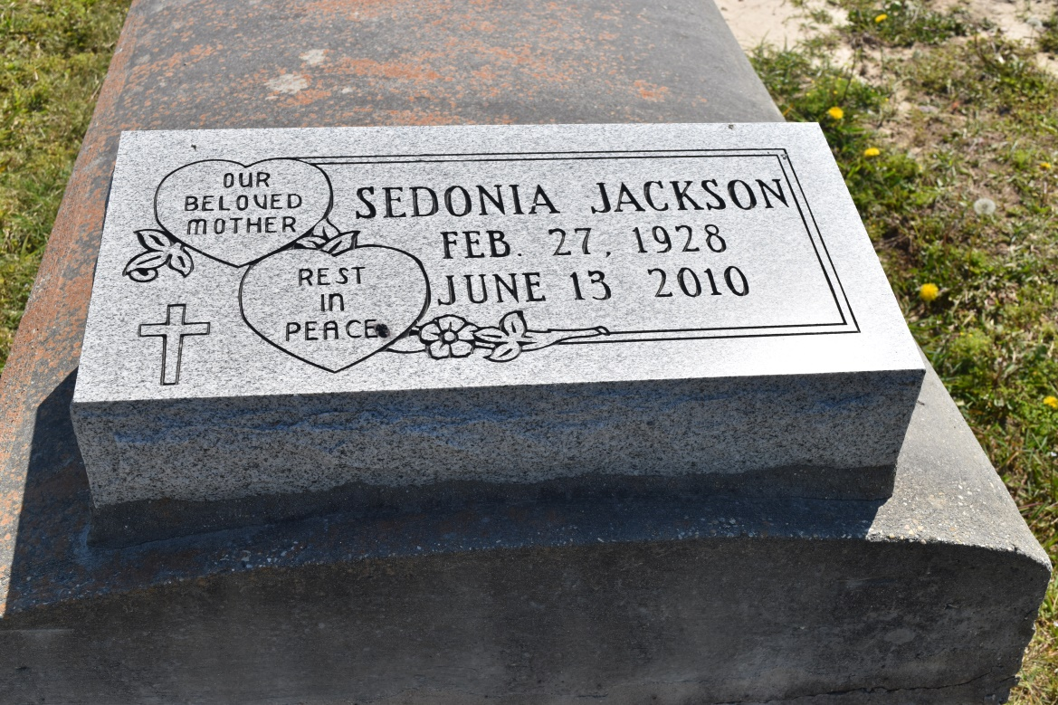

Sedonia Jackson, of LaPlace, LA, on Sunday, June 13, 2010 departed this life. Daughter of the late Willie Jackson and Beatrice Barre. Wife of the late Henry Sullivan, Sr. Mother of Carolyn Sullivan Carter, Henry Sullivan, Jr. and Jheri Sullivan Rivers. Sister of the late Thelma, Leola and Mercedes Jackson. Survived by sons- and daughters-in-law, grandchildren, great-grandchildren, nieces, nephews, cousins, other relatives and friends.
The family wishes to thank Egan Home Nursing, River Region Hospice, Danielle Coleman, Zion Travelers M.B.C., Ricky Jackson and Triplett Fly for support during her extended illness.
Relatives and friends of the family, also pastors, officers and members of the Zion Travelers B.C., neighboring churches, 1st Baptist Church, Round Rock, Texas; employees of St. John Parish School Board, Shell Oil, South LA Port Commission, Council on Aging, and South East LA War Veteran Home are invited to attend the Funeral Services on Friday, June 18, 2010 at 10:30 a.m. from the Zion Travelers B.C., Walnut St., LaPlace, LA. Visitation at the Church after 9:30 a.m. Interment Zion Travelers Cemetery, Reserve, LA. The Baloney Funeral Home, L.L.C., 399 Earl Baloney Dr., Garyville, LA, Information: (985) 535-2540,
In Charge of Arrangements.

Times-Picayune, The (New Orleans, LA) - Thursday, June 17, 2010
Contributed by Jane Edson

