Derek E. Johnson Sr.
July 20, 1961 – April 15, 2009

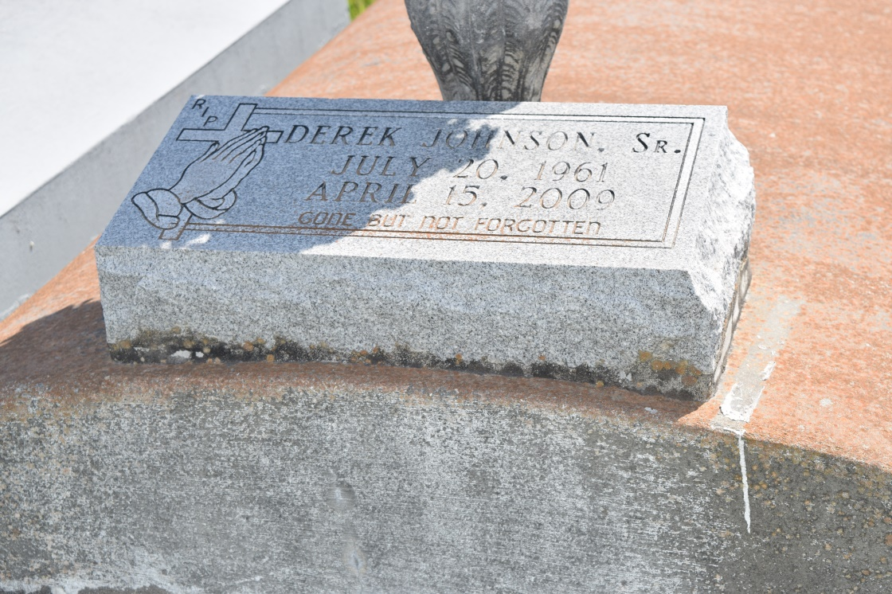

Derek E. Johnson, Sr. of Laplace, LA at his residence on Wednesday, April 15, 2009. Son of the late Ruby Johnson. Husband of Dorothy Johnson. Father of Delandra and Derek Jr. of LaPlace, La., Chris and Cracg of Kenner, LA. and Princess Davis of California. Brother of Sedric Johnson. Brother-in-law of Laura (Ahmad) Sly, Brenda (Jackie) Batiste, Gloria (Joseph) Stockman and Beverly Williams. Also survived by (4) grandchildren, nieces, nephews, other relatives and Friends. Age 47 years. Preceded in death by mother and father-in-law Ethel and Walter Morris and a nephew Jackie Batiste, Jr.
A Funeral service will be held on Saturday, April 18, 2009 at 11:00 a.m. from the Providence Baptist Church, 240 Pine St., Laplace, LA. Rev. Willie Smith, officiating. Interment Providence Cemetery, LaPlace, LA.
The Baloney Funeral Home, LLC, 399 Earl Baloney Dr., Garyville, LA, 985-535-2540 in chage of arrangements.

Times-Picayune, The (New Orleans, LA) - Saturday, April 18, 2009
Contributed by Jane Edson

