Florence (Robinson) Jones
Abt. 1941 – January 8, 2019
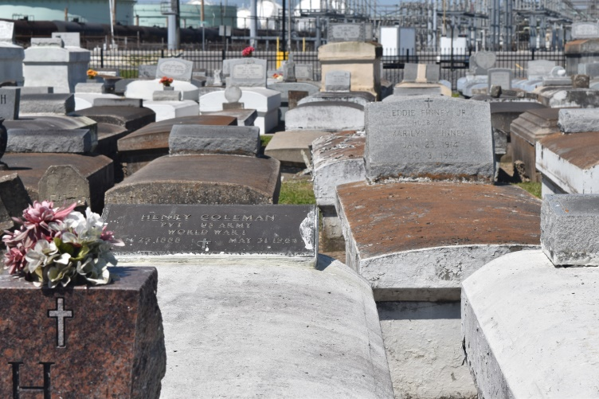

Florence Robinson Jones, age of 78, peacefully transitioned to her eternal home on Tuesday, January 8, 2019 with her family at her bedside. Wife of Edgar Jones, Mother of Demetria (Herbert) Carter, Inga (Reginald) Fluence and Derrick (Melinda) Robinson. Florence is survived by 5 Grandchildren, a devoted niece Irene S. Burl, and a host of nieces, nephews, other relatives and friends.
Family, friends and all neighboring churches are invited to attend the home going service on Saturday January 12, 2019 at 10:00am at First Community Antioch B.C., 10860 Highway 3125 Lutcher, La. Rev. Ferdinand Gaines Pastor and Rev. Gary Bolden Officiating. Visitation at 8:00a.m. Until service time. Interment in Zion Travelers Cemetery, Lyons, La. Professional Services entrusted to the caring staff of Hobson Brown Funeral Home, 134 Daisy St., Garyville, LA 70051. 985-535-2516.
Hobson Brown Funeral Home, 134 Daisy St, Garyville, LA 70051 (985) 535-2516
Published in TheNewOrleansAdvocate.com from Jan. 10 to Jan. 12, 2019

