Andrew Joseph Sr.
November 2, 1931 – March 20, 2012

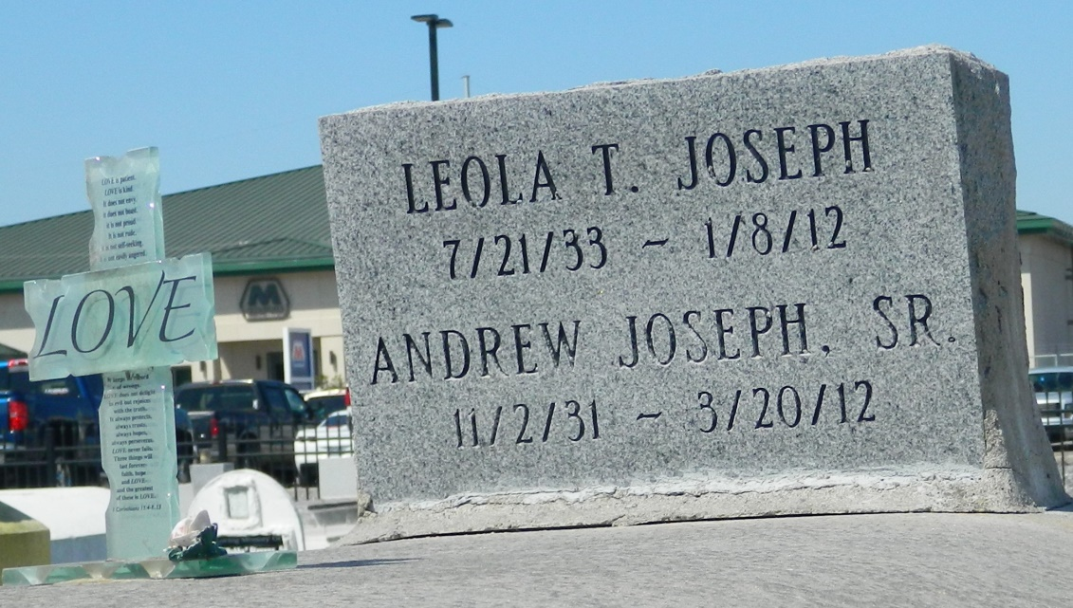

Andrew (Pluck) Joseph, Sr., age 80, was called home on Tuesday, March 20, 2012 in LaPlace, La. Son of the late Robert and Stella Joseph. Husband of the late Leola Joseph. Father of Delores Florian, Ernestine Hewitt, Brenda Mitchell, Billy, Willie, and Michael Joseph. Also survived by a host of grandchildren, great-grandchildren, sons- and daughters-in-law.
Pastors, officers and members of New Pilgrim B.C. and all neighboring churches are invited to attend the Funeral Service on Saturday, March 24, 2012 at 11:00 a.m. at the above named church, 107 Pilgrim Dr., Reserve, La. Rev. Forell Bering Sr., Officiating. Burial in Zion Travelers Cemetery, Reserve, La. Visitation from 10:00 a.m. until service time.
Services entrusted to Hobson Brown Funeral Home, Garyville, La. (985) 535-2516

Times-Picayune, The (New Orleans, LA) - Friday, March 23, 2012
Contributed by Jane Edson

