Elliott Lynn Joseph
May 27, 1979 - June 5, 2022
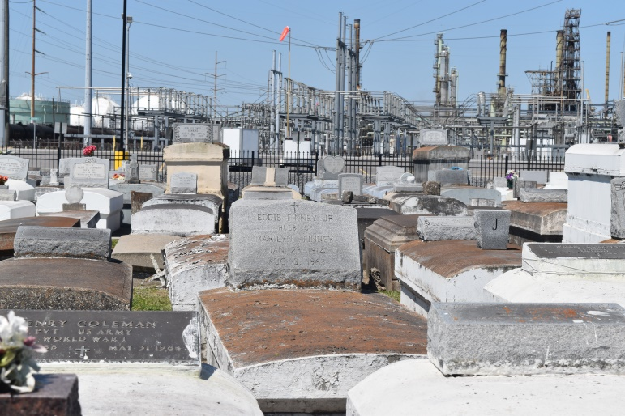
Elliott Lynn Joseph departed this life on Sunday, June 5, 2022 at the age of 43. He was the son of the Shelia Annette Johnson Williams (late Robert Earl Williams, Sr.), father of Edyn LaDavid Joseph, brother of Elizabeth Joseph Perrilloux (Joseph, Sr.) and Terry Joseph Perrilloux (Joquan), Nephew of Earnestine Joseph, Sandra Jackson, Charles Johnson, Sr. (Phyllis), and a host of nieces, nephews, cousins, other family, friends and his loving devoted friend Shannon Perrilloux and devoted loving friend Dayna Perrilloux Mitchell, who will all cherish his memories.
He was preceded in death by his maternal grandparents J. W. Johnson, Sr. and Lubertha Johnson, stepfather Robert Earl Williams, Sr., Aunts, Lillie Hugh and Izola Johnson, Uncle JW Johnson, Jr. and cousins Darryl Johnson, Jr., Kenneth, and Lakeitha Joseph.
Relatives and friends of the family are invited to a Celebration of Life at 11:00 a.m., Thursday, June 16, 2022, Bethlehem Baptist Church 146 E. 20th Street, Reserve, LA 70084. Rev. Dr. Forell Bering, Pastor. In accordance with the CDC guidelines for COVID-19 mask are suggested for all in attendance. Visitation at the above-named church 9:00 a.m. until time of service. Interment Zion Travelers Baptist Cemetery, Reserve, LA. Final Arrangements Entrusted to Patrick H. Sanders Funeral Home & Funeral Directors, Inc. 605 Main Street, LaPlace, LA 70068. For information 985-359-1919.
The Patrick H. Sanders Funeral Home, LaPlace, LA

