Elton Joseph
February 28, 1988 – August 3, 2015

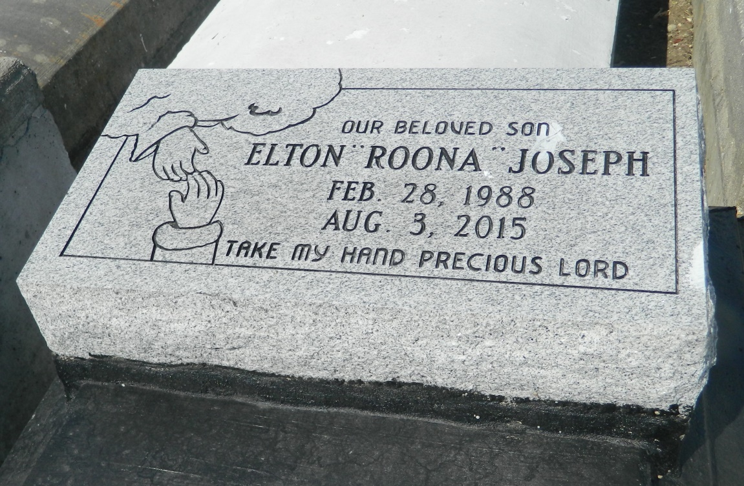

Elton Joseph passed on August 3, 2015. Son of Emma Joseph and Elton Johnson. Brother of Emmanisha Joseph. Survived by relatives and friends.
Funeral service on Monday, August 10, 2015 at Mt. Zion B.C. #1, 144 Little Hope St, Garyville, LA at 11:00am. Viewing at 9:00 am ONLY. Rev. Kent Fredericks Pastor officiating. Internment Zion Travelers cemetery Reserve, LA.
Service Entrusted to Hobson Brown Funeral Home, Garyville, La 70051, 985-535-2516.

Times-Picayune, The (New Orleans, LA) - Sunday, August 9, 2015
Contributed by Jane Edson

