Kenneth M. Joseph
September 29, 1979 – March 2014
LaKeitha M. Joseph
June 8, 1984 – March 2014

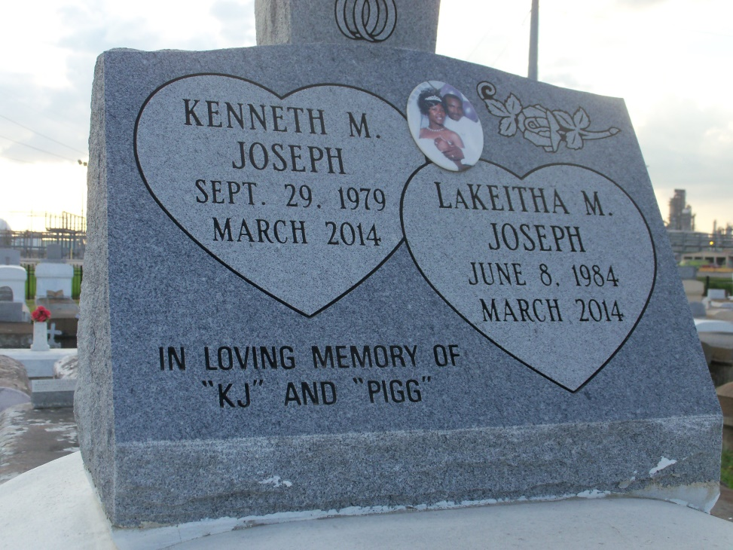
Photo by GeniHound

Reserve couple's killings baffle friend, relatives waiting for answers
From his front lawn in Reserve, Joshua Jones can peer down the street and see the house that Kenneth and Lakeitha Joseph called home. More than six weeks after the couple disappeared, and even though their bodies have since been found in the Gulf Intracoastal Waterway in eastern New Orleans, he still figures to see his friend in the yard.
"Almost everyday, I look down there, expecting to see him in his red hoodie," Jones said Thursday. "It's hard. It's difficult."
Now he and the dead couple's relatives are waiting on answers to who killed 34-year-old Kenneth Joseph and his wife, Lakeitha, 29, and why. "We just can't believe that this could happened to two of the sweetest, nicest people," Jones said, shaking his head. "It's just so many unanswered questions."
The couple had been married almost 10 years. They did not have children together, but Kenneth Joseph has a child from a previous relationship, relatives have said. Jones said he knew Kenneth Joseph for about 12 years. He said he and the couple's relatives remain baffled by their deaths, especially the horrific manner in which authorities suspect the couple were deliberately drowned, cast into 18 feet of water with 30-pound weights tied to their feet.
Sure, Jones said, he's heard the rumors that the couple were killed over drugs, but he disputes it. Kenneth Joseph was convicted of possessing cocaine in 1998 and again in 2004, and he has several unresolved misdemeanor charges of possessing marijuana, according to court records.
"There are a thousand rumors flying, " Jones said. "No, he was not involved in drugs. She had a nice little job as a security guard. He was cutting grass and cut hair."
Jones said relatives asked him to go into the Josephs' house on Feb. 19, after they found the door unlocked and their calls to the phone had gone unanswered since the previous day. "They were afraid to go in because they didn't know what they would find," he said.
He found the house ransacked. Dresser drawers had been pulled out and clothing dumped on the floor. The sofa was overturned, as was the mattress from the bed, he said.
It was then that relatives reported the couple missing to the St. John the Baptist Parish Sheriff's Office and mounted a missing person campaign of their own. They held prayer vigils and printed fliers and made T-shirts emblazoned with the couple's pictures in front. Jones said he distributed hundreds of fliers in an effort to find them.
While saddened by their deaths, he said, there has of late been a measure of comfort for the family, with the discovery of the bodies. They were finally able to hold a funeral and properly lay the Josephs to rest.
"But we still don't know who did it or why they did it. What's the whole motive behind it," Jones said. "They are holding on, they are just trying to get down to the bottom of it and see who is behind it."
. . . . . . .
CORRECTION: An earlier version of this story misstated the depth of the Gulf Intracoastal Waterway. Vic Landry, a Corps of Engineers dredging project manager, said the waterway is 18 to 19 feet deep at the Paris Road bridge, where the bodies were found. The bridge is 137 to 140 above the water, said a spokeswoman for the state Department of Transportation and Development.
Contributed by Jane Edson

