Larry Joseph Sr.
October 9, 1928 – June 20, 2007

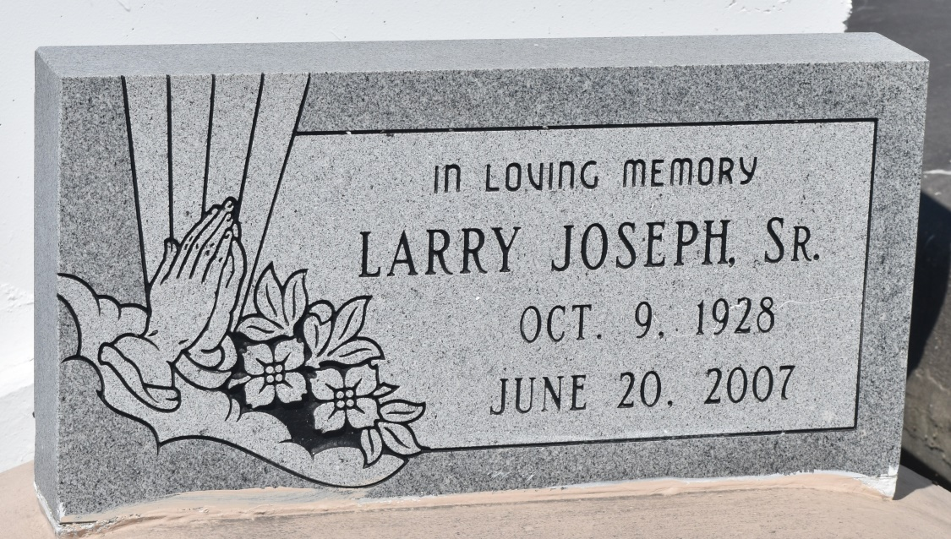

Larry Joseph, Sr. departed this earthly life on Wednesday, June 20, 2007 at River Parish Hospital of Laplace, LA. Son of the late Ethel and Celestin Joseph, Sr. Beloved husband of Marie R. Joseph of Mt. Airy, LA. Loving father and father-in-law of Larry Jr. and Sandy Joseph, Perry and Joycelyn Joseph of Laplace, LA, Alosia J. McKinley, Kylon Joseph of Mt. Airy, LA, Cornell and Samantha Joseph of Joplin, Missouri, Brian and Erline Joseph of Atlanta, Georgia, Staffon and Brandy McKinley of Killeen, TX, and the late Kenneth Joseph. Brother of Helen Wilfred, Glendora Grant, Stanley Joseph and the late Celestin Joseph, Jr., Sybil Joseph, Lionel Joseph and Adline Alexis. Brother-in-law of Julius Roussell, John Roussell, Zenobia Taylor, Eugene Roussell and the late Roland Roussell, Sr., Veronica Joseph and Georgiana Rixner. Also survived by 27 grandchildren, 19 great grandchildren, a host of nieces, nephews other relatives and friends. Age 78 years.
Relatives and friends of the family, also pastors, officers and members of The St. John Missionary Baptist Church of Mt. Airy, LA and all neighboring Churches are invited to attend the Funeral Services on Saturday, June 23, 2007 at 11:00 AM at St. John Missionary Baptist Church, 287 Daffodil St., Mt. Airy, LA. Rev. Gary Bolden, Sr., Officiating. Interment in Zion Travelers Cemetery of Lion, LA. Visitation will be at the church from 9:00 AM until service time.
Bardell's Mortuary of Mt. Airy, LA in charge. Information: 985-535-6837

Times-Picayune, The (New Orleans, LA) - Friday, June 22, 2007
Contributed by Jane Edson

