Leola (Taylor) Joseph
July 21, 1933 – January 8, 2012

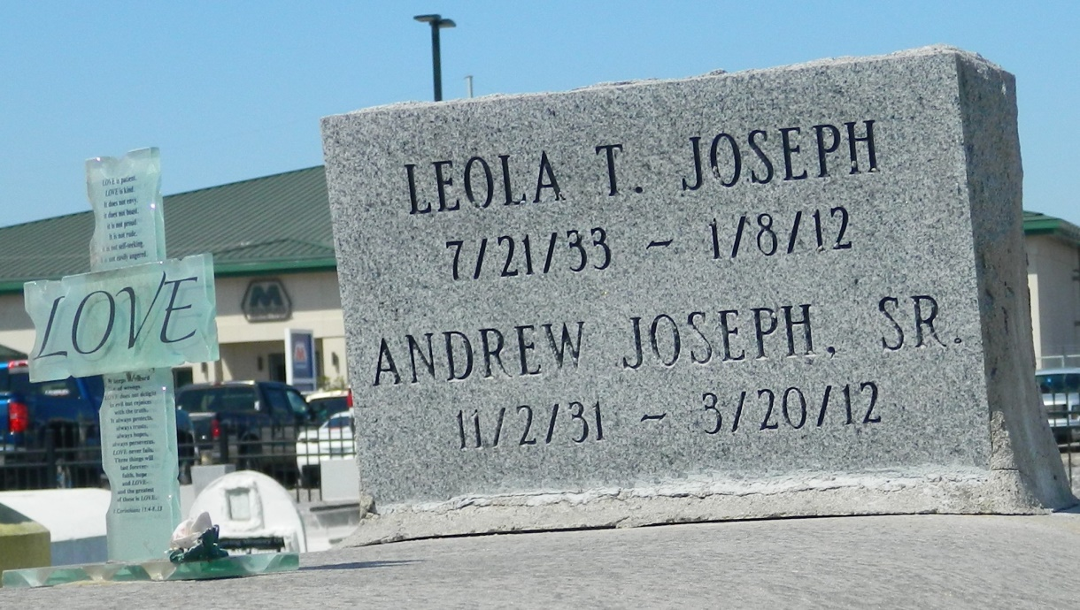

Leola (Dora) Joseph, age 78, was call home on Sunday, January 8, 2012 in River Ridge La. Daughter of the late Sam and Tihelia Taylor. Wife of Andrew Joseph. Mother of Dolores Florian, Ernestine Hewitt, Brenda Mitchell, Billy, Willie, and Michael Joseph. Also survived by a host of grandchildren, great-grandchildren, sons- and daughters-in-laws.
Pastor, officers, and members of New Pilgrim B.C. and all neighboring churches are invited to attend the Funeral Services on Saturday, January 14, 2012 at 10:00 a.m. at the above named church, 107 Pilgrim Dr., Reserve, La. Rev. Forell Bering, Sr., Officiating. Interment in Zion Travelers Cemetery Reserve, La. Visitation from 9:00 a.m. until service time.
Service Entrusted to Hobson Brown Funeral Home, 134 Daisy St. Garyville, La., 70051,
(985) 535-2516

Times-Picayune, The (New Orleans, LA) - Friday, January 13, 2012
Contributed by Jane Edson

