Marie (Roussell) Joseph
December 29, 1932 – July 4, 2009

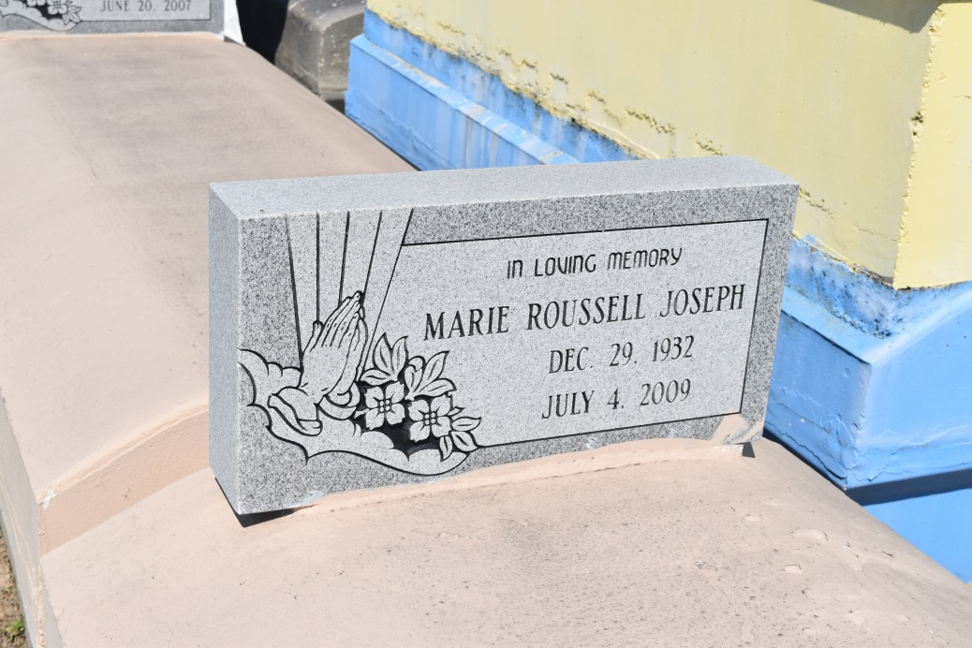

Marie Roussell-Joseph departed this earthly life on Saturday, July 4, 2009 at Well Star Cobb General Hospital of Austell, GA. Daughter of the late Junius Roussell, Sr. and Mazie Roussell-Edward. Stepdaughter of Welmer Edward. Wife of the late Larry Joseph, Sr. Beloved mother of Larry Jr. (Sandy), Cornell (Samantha), Perry (Joycelyn), Brian (Erline) and Kaylon Joseph, Alosia, Staffon (Brandy) and Michael (Vernique) McKinley, the late Kenneth Joseph, Sr. and Maria Davis. Loving sister of Junius Jr. (Abbie Mae), John (Connie), and Eugene (Rene) Roussell, Zenobia (Robert) Taylor, the late Roland Roussell, Sr., Georgia, Rixner and Veronica Kirkwood. Sister-in-law of Mary Roussell-Pinedo and Godfrey Rixner, Jr. Stepsister of Barry Edwards. Also survived by 30 grandchildren, 35 great-grand-children, nieces, nephews, other relatives and friends. A deceased grandchild, Maria Alosia McKinley. A native and resident of Mt. Airy, LA. Age 75 years.
Relatives and friends of the family; also pastors, officers and members of St. John Missionary Baptist Church, Shiloh B.C. of Dallas, GA, Tchoupitoulas Chapel, Hopeful Triumph B.C., St. Mark B.C., Nalco, Kaiser and St. John School Systems are invited to attend the Funeral Services on Saturday, July 11, 2009 at 11:00 a.m. at St. John Missionary Baptist Church, 287 Daffodil St., Mt. Airy, LA. Rev. Gary Bolden, officiating. Interment in Zion Travelers Cemetery, Reserve, LA. Visitation will be at the above named church from 9:00 a.m. until service time.
Bardell's Mortuary of Mt. Airy, LA in charge. Information: (985) 535-6837.

Times-Picayune, The (New Orleans, LA) - Friday, July 10, 2009
Contributed by Jane Edson

