Alex Kelson Jr.
April 22, 1924 – August 1, 2007

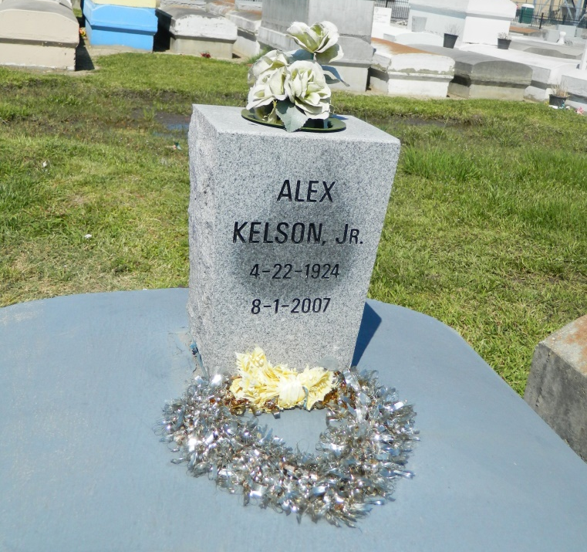

Alex (Long Boy) Kelson, Jr., of Reserve, LA, at River Parishes Hospital on Wednesday, August 1, 2007. Son of the late Alex Kelson, Sr. and Albertha Green Kelson. Beloved husband of Mary Kelson. Father of Larry, Alex III (Michelle), Eric, Jefferi (Monja) Kelson, Donna Washington, Kathryn Pack (Larry), Anita Washington, Joyce Theriot (Phillip), Abbie Roussell (Junius) and the late Paul Kelson. Brother of Bertha Mae Smith, Ernest Kelson, Melvin Kelson, David Kelson and the late Prince Kelson and Isabella Hamilton. Also survived by a host of grandchildren, great-grandchildren, nieces, nephews, cousins and friends. A native of Burnside, La. and a resident of Reserve, La. Age 83 years.
Relatives and friends of the family, also Pastor, Officers and Members of the Greater New Plymouth Rock B.C. and neighboring churches, employees of ASI Credit Union, Dupont Chemicals, Ochsner-Kenner, BE&K are invited to attend the Funeral Services on Saturday, August 4, 2007 at 11:00 am from the Greater New Plymouth Rock B.C., 110 Northwest 13th St., Reserve, La. Rev. David B. Carter officiating. Interment Zion Travelers Cemetery, Reserve, La. Visitation at the church after 9:00 am.
The Baloney Funeral Home, L.L.C., 399 Earl Baloney Dr., Garyville, La. 70051, (985) 535-2540 in charge of arrangements.

Times-Picayune, The (New Orleans, LA) - Friday, August 3, 2007
Contributed by Jane Edson

