Larry Louis Kelson
April 25, 1948 - January 22, 2024

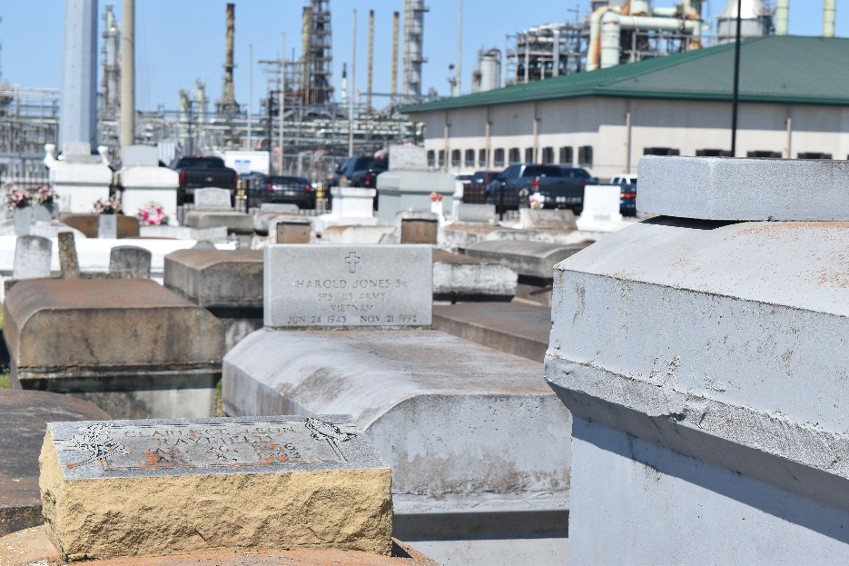

On Monday, January 22, 2024, Larry Louis Kelson peacefully departed this earthly life. Raised in a Christian home, Larry was born on April 25, 1948, to the union of the late Alex Kelson, Jr. and Mary Taylor Kelson. He was the eldest of eight children, raised along with Abbie Roussel and Joyce Theriot. Larry gave his life to Christ and the joined Greater New Plymouth Rock Baptist Church in Reserve, LA. He was educated in the St. John the Baptist public school system. He worked for twenty-four years for the City of New Orleans as a heavy equipment operator.
Larry met and married the late Shirley C. Kelson. To their union one daughter was born: Tonya Chambliss. Larry was also the father of Patricia Martin. He was the loving grandfather of Larinika, Dashia, and the late Tiequinnicca; and great-grandfather of Jaden, Aaliyah, and Taylor. Larry’s children and grandchildren gave him great joy and contentment. Left to cherish precious memories of Larry are his children, grandchildren, and great-grandchildren.
Also left to cherish lasting memories are his siblings: Donna Washington, Kathryn Pack, Anita Washington, Eric Kelson, Alex Kelson (Michelle), Jeffrey Kelson (Monja); and a host of nieces and nephews. Larry was preceded in death by his parents: Alex and Mary T. Kelson; brothers: John Brown and Paul Anthony Kelson; two brothers-in-law: Larry Pack and Gerald Washington; Godparents: Rosetta T. Miles and Rev. Cureaux; and a host of aunts, uncles, and cousins.
A public visitation will be held on Thursday, January 25, 2024 at Treasures of Life Funeral Services, 315 East Airline Hwy., Gramercy, LA 70052 from 3PM-5PM. A Celebration of Life honoring Larry L. Kelson will be held on Friday, January 26, 2024, at Greater New Plymouth Rock Baptist Church, 110 NW 13th St., Reserve, LA 70084. Visitation at 10AM with service to follow at 11AM. Interment at Zion Travelers Cemetery in Reserve.

Treasures of Life Funeral Services, Gramercy, Louisiana
January 25, 2024

