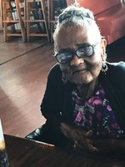
Mary (Taylor) Kelson
1925 – October 7, 2017
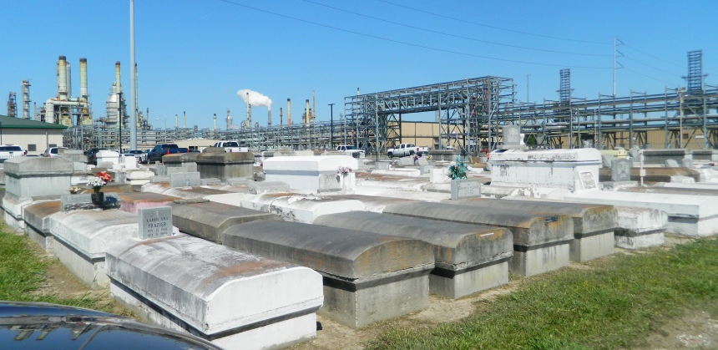
Mary T. Kelson of Reserve, La. departed this earthly life at Ochsner Hospital, Jefferson, La. on Saturday October 7, 2017. Wife of the late Alex (Long Boy) Kelson Jr and daughter of the late Jeff and Katherine Jackson Taylor. Beloved mother Larry L. Kelson, Donna Kelson Washington, Kathryn Kelson-Pack, Anita Kelson Mitchell, Eric Kelson, Alex (Michelle) Kelson III, Jefferi D.(Monja) Kelson, Abbey Roussell, Joyce Theriot and the late John Brown Jr. and Paul A. Kelson. Sister of the late Rosetta T. Miles and Madison Taylor, and the devoted aunt of Frank Miles (Elaine). Survived by a host of grandchildren, great grandchildren, great great grandchildren, nieces, nephews, cousins and friends. A native and resident of Reserve, La. age 92 years.
Relatives and friends of the family also pastor, officers, and members of the Greater New Plymouth Rock B.C. and neighboring churches, employees of Ochsner-Kenner Campus, St. John Parish Utilities, Folgers Coffee, Lighthouse for the Blind, Metropolitan Dialysis, Ochsner Hospital Jefferson Campus. Dupont Chemical Plant are invited to attend a gathering of friends and family on Friday October 13, 2017 from 3-5 pm at Treasures of Life Funeral Services 315 E. Airline Hwy. Gramercy, La. 70052. Funeral services on Saturday October 14, 2017 at 11:00am from Greater New Plymouth Rock B.C. 110 N.W. 13th St. Reserve, La. Rev. David B. Carter officiating. Interment Zion Travelers Cemetery Reserve, La. Visitation at the church from 9:00 am until service time.
Final care entrusted to Treasures of Life Funeral Services 315 E. Airline Hwy. Gramercy, La.
“When someone you love becomes a memory that memory becomes a TREASURE”
www.treasurefunerals.com (accessed 10/18/2018)

