Melvin Kelson Jr.
January 11, 1972 – August 9, 2007

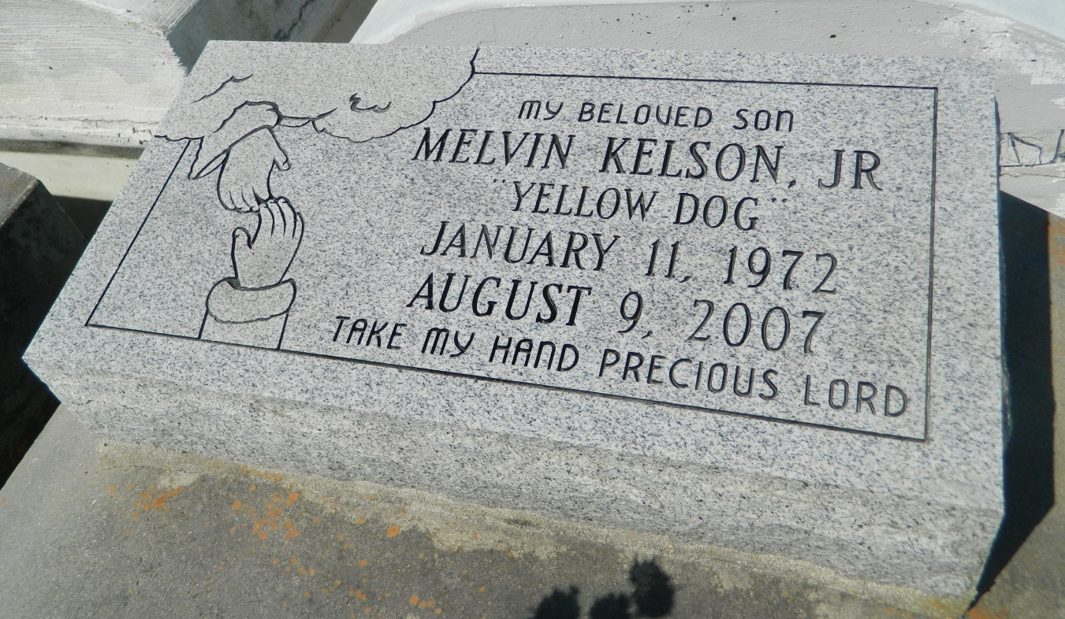

Melvin "Yellow Dog" Kelson, age 35, departed this life on Thursday, August 9, 2007 in Reserve, La. Son of Melvin Kelson, Sr. Father of Selah Kelson and step father of Asia and Etana Sena. Brother of Edward (Gailynn) Kelson, Sr., Darrin (Carolyn) Kelson, Sr., Percy (Lenora) Kelson and a devoted sister, Vanessa Hogan (Glenn Miller). Also survived by his companion, Nisha Sena of Aurora, Colorado; and a host of aunts, uncles, nieces, nephews, other relatives and friends. A native of New Orleans, La. and resident of Reserve, La.
Pastors, officers, and members of Milesville Memorial Church of God in Christ, Providence Memorial B.C. and all Neighboring Churches, are invited to attend the funeral service on Friday, August 17, 2007 at 11:00a.m. from M.M.C.O.G.I.C., 129 Apple St., LaPlace, LA. Bishop Ronald Frank Pastor, Bishop Lawerence St. Cyr, Officiating. Interment in Zion Travelers Cemetery, Reserve, La. Providence Memorial Park Cemetery, Metairie, La. Visitation at the church on Thursday from 5:30-7:30 p.m. and on Friday from 9:00 a.m. until service time service. (ONLY).
Service entrusted to HOBSON BROWN FUNERAL HOME, Garyville, La,
Times-Picayune, The (New Orleans, LA) - Thursday, August 16, 2007
Contributed by Jane Edson

