Melvin Kelson Sr.
September 30, 1928 – January 22, 2013

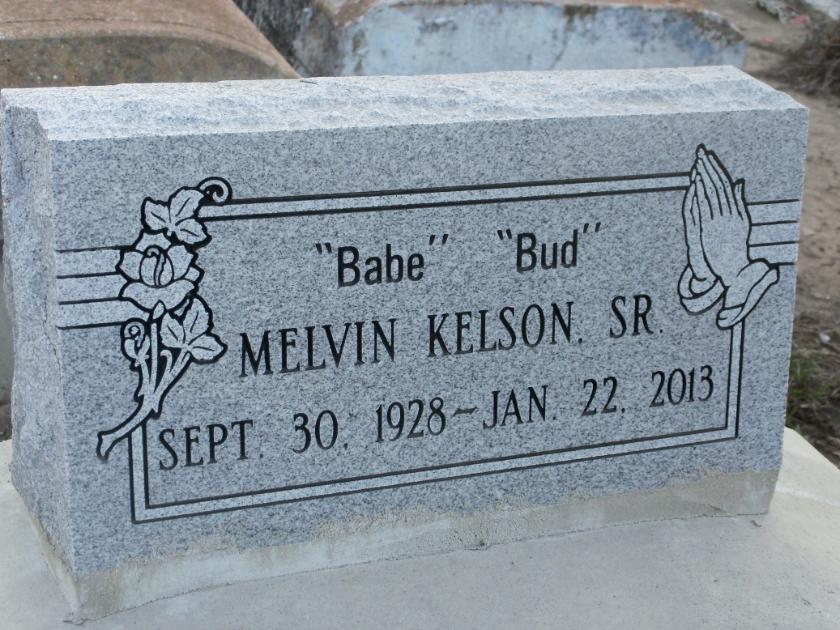
Photo by GeniHound

KELSON Melvin "Bud" "Babe" Kelson, Sr. age 84 "entered into eternal rest" on Tuesday, January 22, 2013 at his residence.
Father of Vanessa Hogan, Edward Kelson, Sr. (Gailyn), Percy Kelson (Lenora), Darrin Kelson, Sr. (Carolyn), Carolyn & Sherita Atkins. Brother of Bertha Mae Kelson of Laplace, LA, Ernest Kelson, Sr. (Gwen) of New Orleans and the late Melvin Kelson, Jr. Also survived by 10 grandchildren, 4 great-grandchildren and a host of other relatives and friends.
Relatives and friends of the family also pastors, officers and members of Second Good Shepherd B. C., New Dimension CFM, Employees of Sam's Club, RTA, Winn Dixie, Willie's Chicken Shack and Lakeside Hospital are invited to attend the Funeral Service at Second Good Shepherd M. B. C. 619 Second Street New Orleans, LA on Saturday, February 2, 2013 at 9:00 AM Rev. Melvin Jones Jr. - officiating. Visitation 8:00 AM - 9:00 AM
Interment, Zion Travelers Cemetery Reserve, LA.
Published in The Times-Picayune (New Orleans, LA) from January 30 to February 1, 2013.

