Henry B. “Pat” Knight
October 12, 1924 – December 21, 2000

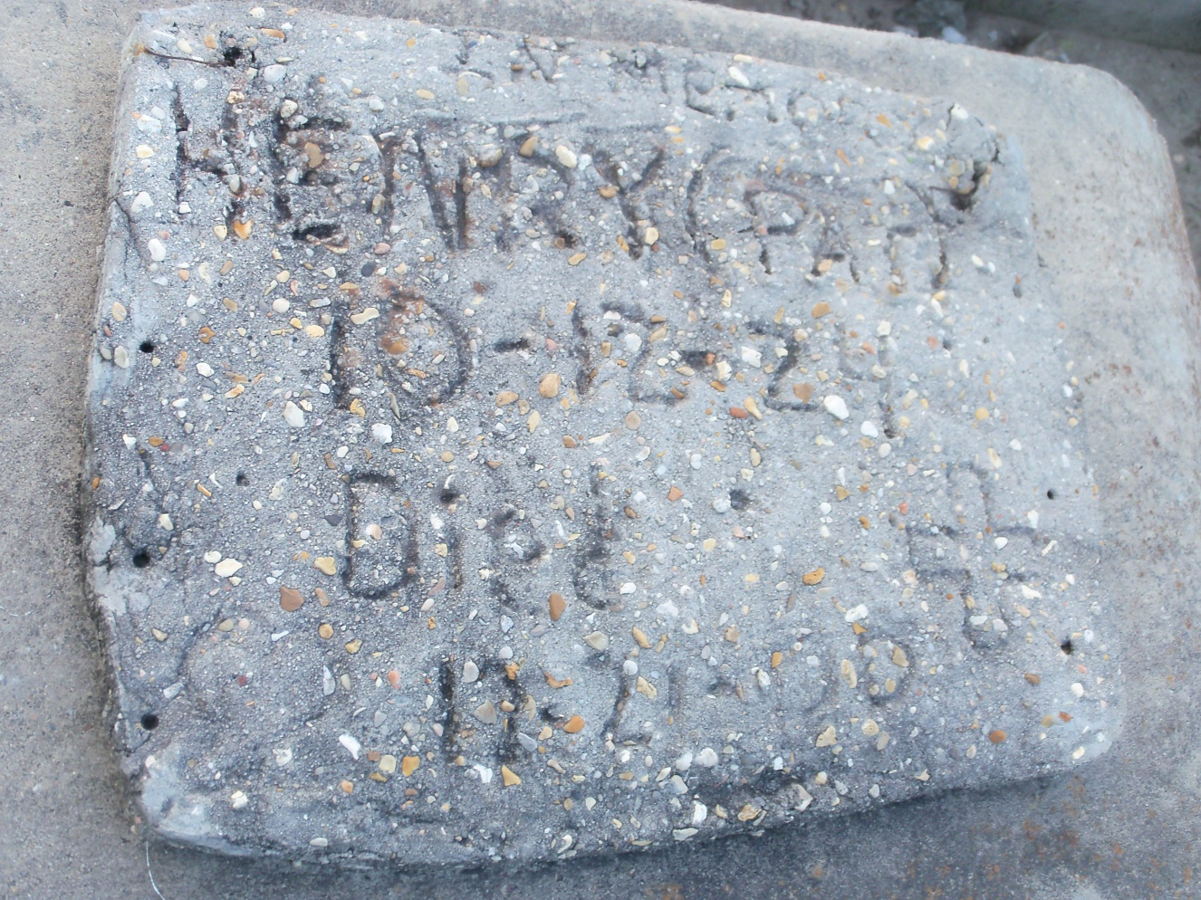
Photo by GeniHound

GARYVILLE - Henry B. "Pat" Knight, 78, a native of Wagner, Miss., and resident of Garyville and Reserve, died Dec. 21. He was the son of the late Ben and Alice Knight. He was also the uncle of Rebecca Davis, Rosalie Clark, Booth Knight and Joseph, Willie Mae, Elnora, the Rev. James, Leon, Annette and Virginia Davis. Services are today at 11 a.m. at New Hopeful Baptist Church, Garyville, with interment at Zion Travelers Cemetery, Lions. Visitation starts at 10 a.m.

L'Observateur (La Place, LA) - Saturday, December 30, 2000
Contributed by Jane Edson

