Alexander Love
August 12, 1952 - August 26, 2023

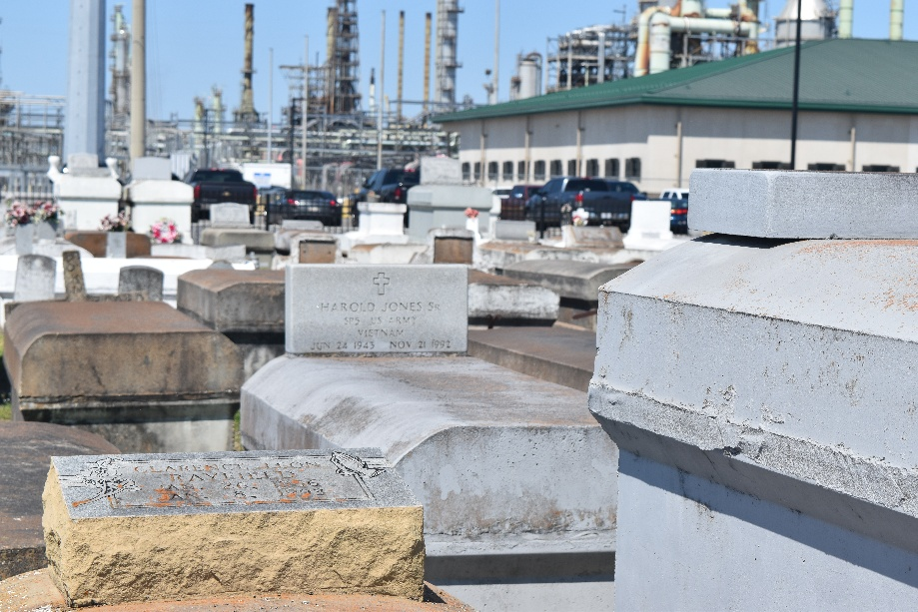

Alexander Love, 71, was born on August 12, 1952 in New Orleans, LA to the union of Ernest Love, Sr. and Delores Lemon Love. He entered eternal rest on August 26, 2023. He was a native of Mt. Airy, LA.
He accepted Christ as his Lord and Savior and was baptized by the late Pastor David Carter of Greater New Plymouth Rock Baptist Church in Reserve, LA. He attended Sixth Ward Elementary School in Garyville, LA and Fifth Ward High School in Reserve, LA.
Preceding him in death are his parents: Ernest Love, Sr. and Delores Lemon Love; brothers: Alfred, James, and Clarence Love; and sisters: Earnestine Lacey, Rosalie Stephens, Vera and Sharon Love.
Alexander is survived by his brothers: Ernest Love, Jr. of Los Angeles, CA, Rev. Henry Love (Josephine) of Laplace, LA, and Charles Love, Sr. (Donna) of Gonzales, LA; sisters: Geraldine Orleanas (Juan) of Lancaster, TX and Bobbie Jean Gomes (Leopold) of Saint Croix, Virgin Islands. He leaves to cherish his memory a host of other relatives and friends.
A Celebration of Life honoring Alexander Love will be held on Thursday, September 7, 2023, at Treasures of Life Funeral Services, 315 E. Airline Hwy., Gramercy, LA 70052. Visitation 9AM-11AM. Service will begin at 11AM. Interment to follow at Zion Travelers Cemetery in Reserve, LA.

Treasures of Life Funeral Services, Gramercy, Louisiana
September 6, 2023

